Monroe County
Health Department
2022-2027 IPLAN
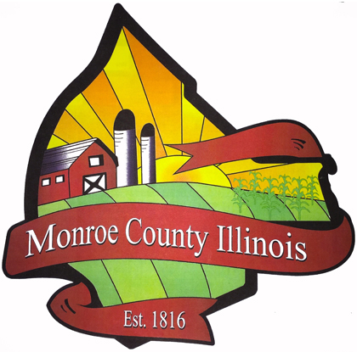

Table of Contents
Board of Health Documentation Letter ……………………………………………………………………… 3
Executive Summary …………………………………………………………………………………………………….... 4
Community Health Assessment …………………………………………………………………………..… 4-23
Demographics and Socioeconomic Indicators ……………………………………………….. 7-10
General Health and Access to Care ………………………………………………………………. 10-13
Maternal & Child Health …………………………………………………………………………………. 13-15
Chronic Disease ……………………………………………………………………………………………… 15-17
Infectious Disease ………………………………………………………………………………………….. 17-19
Environmental/Occupational/Injury ……………………………………………………........... 20-22
Sentinel Events …………………………………………………………………………………………………… 22
Priorities ……………………………………………………………………………………………………........... 23
Community Health Plan ……………………………………………………………………………………….. 23-37
Introduction ………………………………………………………………………………………………..…. 23-24
COVID-19 ……………………………………………………………………………………………………….. 25-29
Oral Cavity, Pharyngeal, and Esophageal Cancer ……………………………………….. 29-33
Cardiovascular Disease ……………………………………………………………………………….. 33-37
Conclusion ………………………………………………………………………………………………………….. 37
Appendix A Meeting Roster …………………………………………………………………………………………. 38
Appendix B COVID-19 Worksheets …………………………………………………..……………………. 39-40
Appendix C Oral Cavity, Pharyngeal, and Esophageal Cancer Worksheets …………. 41-42
Appendix D Cardiovascular Disease Worksheets ………………………………………………… 43-44
Appendix E Community Survey and Results ….…….....…………………………………………… 45-46
References ………………………………………………………………………………………………………………. 47-52

Executive Summary
Since its introduction in 1994, The Illinois Project for Local Assessment of Needs (IPLAN) has sought to identify and address health issues pertinent to local communities throughout the state of Illinois. The integrative nature of the IPLAN offers collaboration between local health departments, the public, and other organizations, enabling the creation of sustainable solutions to identified health problems. Health departments must develop new plans every five years to retain certification by the state of Illinois. This document has been created for the 2022-2027 term and intends to remedy the issues the community has deemed most important. The IPLAN process has increased health awareness in the community and has improved the planning and functioning of the Monroe County Health Department.
The three health priorities for the 2022-2027 IPLAN are COVID-19, cancer (oral cavity, pharyngeal, and esophageal), and cardiovascular disease.

Community Health Needs Assessment
- Purpose
In order to improve the overall health of Monroe County residents, accurate research in regards to health status must be obtained. The community health needs assessment ensures that the health department stays up to date on new data pertaining to the health of county residents, while taking into account the specific issues affecting particular populations within it. The assessment will be used to identify the health issues most prevalent in the county, and these concerns will be prioritized for the 2022-2027 plan.
Data and statistics serve as the foundation of the following comprehensive public health plan for Monroe County. The Monroe County Board of Health and health department administrator will utilize this information to guide the department in program development, utilization of funds, and to develop community outreach initiatives. Funding limitations have the potential to greatly affect how the Monroe County Health Department can respond to the needs of the community. The department will concentrate its efforts in utilizing existing funding, as well as pursuing additional resources to mitigate the issues caused by the three topics chosen.
- Community Participation
Due to the COVID-19 pandemic, in-person meetings between the Monroe County health department and external organizations and individuals were limited. Aside from input from the health department and board of health, the most significant contribution in determining the health priorities was derived from a self-report survey administered to the public. This survey was posted on the Monroe County Health Department website, social media pages, and distributed at COVID-19 vaccination clinics. The public health emergency during this time did not permit face-to-face interaction, and this limitation must be addressed when considering the plan put forth.
- Methods
Data was examined was from multiple sources. Statistics from previous IPLANs were compared to current information to determine trends for Monroe County. The most recent data available was utilized. References include, but are not limited to:
- Centers for Disease Control (CDC)
- County Health Rankings & Roadmaps
- Healthy People 2030
- Illinois Health and Hospital Association
- Illinois Department of Healthcare and Family Services
- Illinois Department of Public Health
  - IQuery
  - Vital Statistics
  - Behavioral Risk Factor Surveillance System (BRFSS)
- Illinois Department of Transportation
- Illinois Youth Survey
- United States Bureau of Labor Statistics
- United States Census Bureau
  - QuickFacts
  - Small Area Income and Poverty Estimates (SAIPE)
  - Small Area Health Insurance Estimates (SAIHE)
- United States Department of Health & Human Services
- United States Food & Drug Administration
- National Institutes of Health
Unfortunately, recent data was limited in some areas, including sentinel events. Data may also be limited or unavailable in certain categories due to extremely low frequency. Clarification will follow when data is unavailable to explain potential causes for these limitations.
- Results
Information derived from the following health needs assessment show a few areas that need improvement. Potential changes that could be made to make a difference in the health of county residents include:
- Constructing a hospital within county borders
- Improvements needed in preventing, detecting, and treating chronic disease
- Reducing the behavioral determinants of both chronic and infectious disease
- Reducing the rate of STD transmission
- Increasing immunization rates
- Reducing lead exposure in children
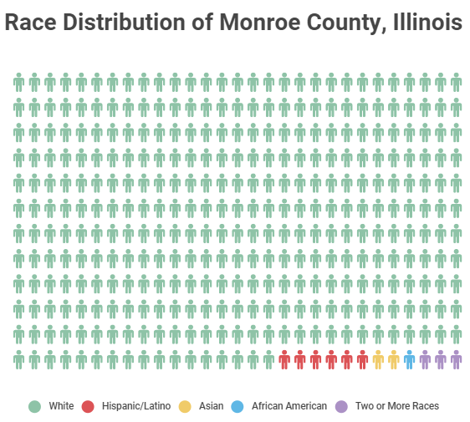
Category 1: Demographics and Socioeconomic Indicators
Figure 1
Monroe County is located in Southwestern Illinois and is situated south of the St. Louis metropolitan area. According to the U.S Census Bureau (2019), Monroe County has an estimated population of 34,637. 97.7% of the population identifies as White, 1.6% as Hispanic or Latino, 0.6% as Asian, 0.4% as African American, and 1.0% as two or more races. 1.9% were born outside of the U.S. The gender makeup of the county is nearly identical to the State of Illinois with 49.8% being male and 50.2% female. Census Reporter (2019) shows that the largest adult age group in the county is 50-59 year olds which account for 16% of the population.
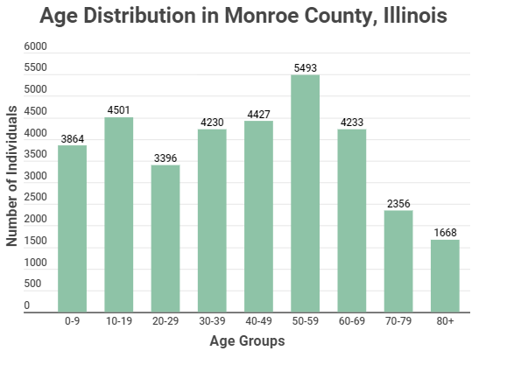
Majority of the population is situated around two centers, Waterloo and Columbia. The county has a total land area of 385 square miles. Monroe County is one of the few counties in Illinois that does not have a hospital within its borders, with the nearest located one mile south of the southern border in Red Bud, Illinois. The nearest major trauma center is located 10 miles to the west in St. Louis County.
Figure 2

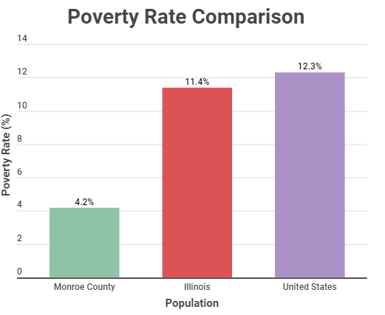
Monroe County is considered a “bedroom community” meaning much of the population commutes to work in St. Louis and St. Clair County. County Health Rankings & Roadmaps (2021) states that Monroe County is considered 59% urban and 41% rural. The median household income is $85,747 and the poverty rate is 4.2% (U.S. Census Bureau, 2019). The Small Area Income and Poverty Estimates (SAIPE) program, shows that the poverty rate in the county is significantly lower than both the state and national average, 11.4% and 12.3% respectively (U.S. Census Bureau, 2019). Currently, Monroe County is the third healthiest county in the State of Illinois (County Health Rankings, 2021).
Figure 3
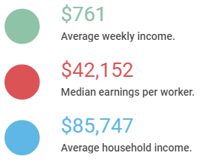
The population of Monroe County has been on the rise since 2000. According to the Illinois Department of Public Health (IDPH), the population of the county in 2000 was 27,619, in 2010 was 32,957, in 2015 was 33,539, and most recently in 2019 is 34,637. These numbers indicate an increase of 1.6% from 2000 to 2010 and a 1.8% increase from 2010 to 2019. However, since 2016, the number of individuals that have moved into the county have decreased. According to the Federal Reserve Economic Database (2021), in 2018, 211 individuals moved out of the county, the largest net emigration since 2011.
Figure 4
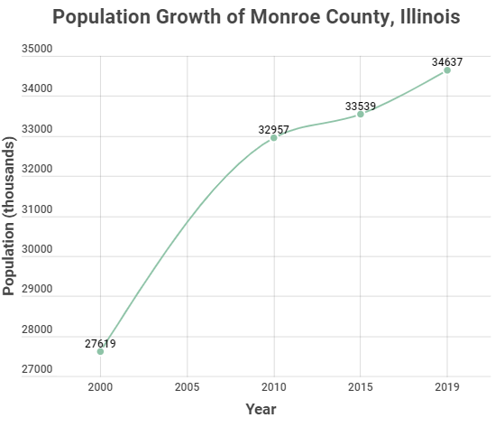
Housing in Monroe County consists of 16.6% rental and 83.4% owned (Census Reporter, 2019). Rental cost data indicates 7.5% falls at less than $500/month, 54.6% $500-$999/month, 29.7% $1000-$1499, 6.4% $1500-1999/month, and 1.8% $2000+/month. The median rental cost for Monroe County was $872/ month (U.S. Census Bureau, 2019). From this data it is evident that the opportunity to pursue low income housing is limited. The median home value in the county was $211,300 (Census Reporter, 2019). This is above the state average of $194,500. 63.9% of the homes in Monroe County have a mortgage.
Figure 5
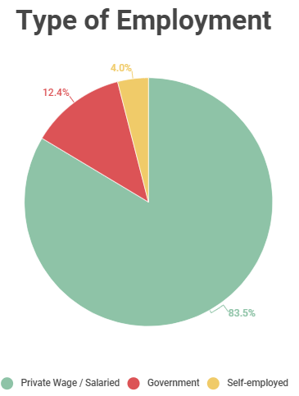
Data indicates that the 2019 poverty rate in Monroe County was 4.2%. The poverty rate for Illinois is 12.5%. According to the Illinois Department of Employment Security (IDES), as of March of 2021, the unemployment rate in Monroe County is 3.3%. Approximately 4.7% % of the households in the county receives food stamps/SNAP benefits. This is significantly lower compared to the state of Illinois where around 11.8% of households receive food stamps/SNAP benefits (U.S. Census Bureau, 2019). 41.8% of households falling below poverty level receive these same benefits. 17% of the children in Monroe County are eligible for free or reduced lunch in schools (County Health Rankings, 2021). 83.5% of individuals are considered private wage or salary workers, 12.4% are government workers, and 4.0% are self-employed. According to the 2019 American Community Survey, 5.6% of the county is unemployed as of 2020. According to the U.S. Bureau of Labor Statistics (2019), the average weekly wage for the employed in Monroe County is $761 per week and the average work week was 38.7 hours. The median earnings per worker was $42,152 and the average household income was $85,747 (U.S. Census Bureau, 2019). The average commute time for the population was 29.6 minutes.
Figure 6
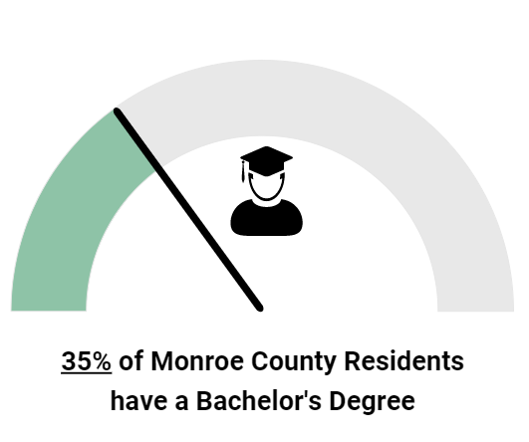
Though migration to the County has decreased slightly in more recent years, those that do move in likely are of high or middle class due to a lack of low income housing. Monroe County has maintained a relatively high household income level and a low number of individuals on public aid. The workforce is shown to be well educated with 35% having Bachelor’s degree or higher (U.S. Census Bureau, 2019). Demographically, Monroe County has seen little to no change in terms of population makeup.
Figure 7

Category 2: General Health and Access to Care
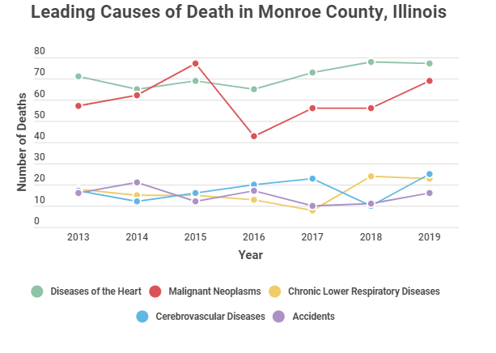
The number of deaths in Monroe County has steadily increased since 2016 (IDPH, 2019). Although the totals have remained relatively stagnant since 2010, the increase may be explained by the overall increase in the older population. 329 residents of Monroe County died in 2019, 77 of which succumbed to diseases of the heart, 69 to malignant neoplasms, and 25 from cerebrovascular diseases. These three causes of death account for approximately 52% of the deaths of Monroe County residents. These three causes of death have remained the most common cause of death in Monroe County residents since 2010, with chronic lower respiratory diseases and unintentional injuries shifting in and out in frequency year by year (IDPH, 2019).
Figure 8
Monroe County is served by area hospitals located within 40 miles of the county. There are five hospitals located in St. Louis, Missouri, two in Belleville, Illinois, and one in Red Bud, Illinois. Monroe County has a medical service area located in Waterloo with pediatric and general practice offices, specialty offices, an outpatient surgery center, imaging, lab, dialysis, and rehab. There are additional general practice and pediatric offices located in Columbia. In 2017, an urgent care center was opened in Columbia on the north end of Monroe County.
Monroe County operates a nursing home in Waterloo with both rehab and long-term care capabilities. There are additional nursing homes in Columbia and Waterloo. Monroe County has four assisted living facilities. Additional facilities are being added as the population of Monroe County continues to age.
Human Support Services is located in Waterloo and offers mental health services and disability assistance. The service has employment and housing services for the mentally handicapped and for people with other disabilities.
As of 2018, 3.8% of the population under age 65 do not have health insurance (U.S. Census Bureau). The number of individuals that do not have health insurance has decreased over the past decade, with 8% being uninsured in 2010 and 4% remaining relatively constant since 2015 (County Health Rankings, 2021). This is below the state average of 8.1% and national average of 10.4% being uninsured. As of 2018, 1.8% of children in the county do not have health insurance, which is well below the US average of 5.2% and Illinois rate of 3.3%.
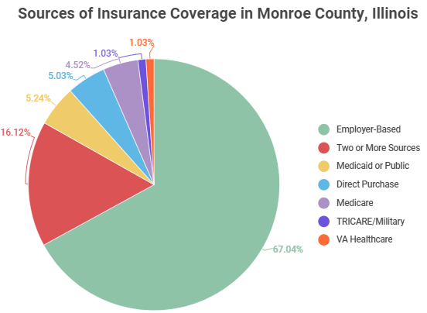
Figure 9

Small Area Health Insurance Estimates (SAHIE) (2018), states that health insurance rates of participation was 95.8% for male and 96.7% for females for the population in Monroe County (U.S. Census Bureau). Along with the steady population increase, Monroe County has also seen an increase in people utilizing the State’s Medical Assistance Program. Monroe County has had tremendous growth in terms of enrollment. The Illinois Department of Healthcare and Family Services (2020) states that the total enrollment in fiscal year 2012 was 1,589 and as of fiscal year 2020 enrollment has reached 2,795.
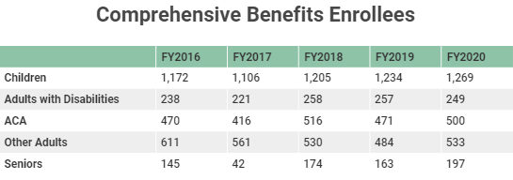

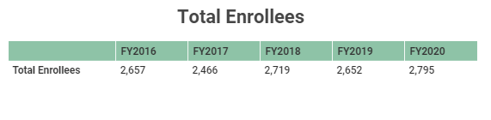
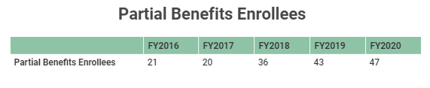
Figure 10
With the population steadily increasing, Monroe County hopes to house their own hospital to serve the needs of the community. Not only would this provide more intensive treatments for residents that are in need of medical attention, but would also provide a vast number of specialists within county limits that can guide individuals with a number of different health concerns, such as diabetes, heart disease, and cancer. With the population continuing to age, prompt treatment during medical emergencies will make the biggest difference in recovery.

Category 3: Maternal and Child Health
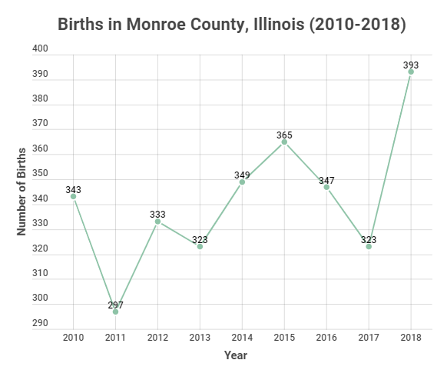
From 2010 to 2018 the number of births per year has remained relatively constant ranging in the 300s (IDPH, 2018). In 2017, the number of births was 323 and in 2018, 393 babies were born. The number of births in 2018 greatly surpassed the previous high in 2015 (365). Of the 393 babies born in 2018, 36 were considered to be of low birth weight, a rate of approximately 9.2%. This is slightly higher than the state average of 8.6% for low birth weights for the same period. The percent of mothers in Monroe County in 2018 who received adequate prenatal care was 89.3% (IDPH, 2018). This is slightly higher than rate in 2017, which was 88.9%.
The percent of births by teenagers in Monroe County in 2018 was 0.8% (IDPH, 2018). This is significantly lower than that of the entire state of Illinois at 4.5%. In 2010, the number of births by teenagers in Monroe County was 3.8% and this number has gradually reduced over the past decade with 2.8% in 2013, and 1.7% in 2016. The percent of babies born to unmarried mothers is 11.7%.
Figure 11
Infant mortality in the county has remained extremely low, partially due to the fact that there are no hospitals within its borders. Data shows the last reported infant death occurred in 2015. Data on abortion rates in the county are also unavailable. All data for abortions indicate fewer than 50 per year, with no solid data available. Due to a smaller population size and lack of healthcare facilities, numbers on these two factors are extremely low and also inaccessible.
As of 2017, a definitive rate of reported domestic violence cases has not been verified. According to the Illinois Criminal Justice Information Authority Center for Victim Studies (2019), the rate ranges from 0-451 per 100,000 population. Though an exact rate is not available, what is known is that domestic violence in Monroe County is significantly lower than the rates in Northern and Central counties. Information in regards to child abuse could not be obtained. Rates are likely so low that they are not accounted for in annual reports put out by the State of Illinois.
Maternal health is strong compared to the rest of Illinois. In particular, the drop in teenage births is most significant. The improvement may be attributed to better sex education in schools, with more resources available to students.

Category 4: Chronic Disease
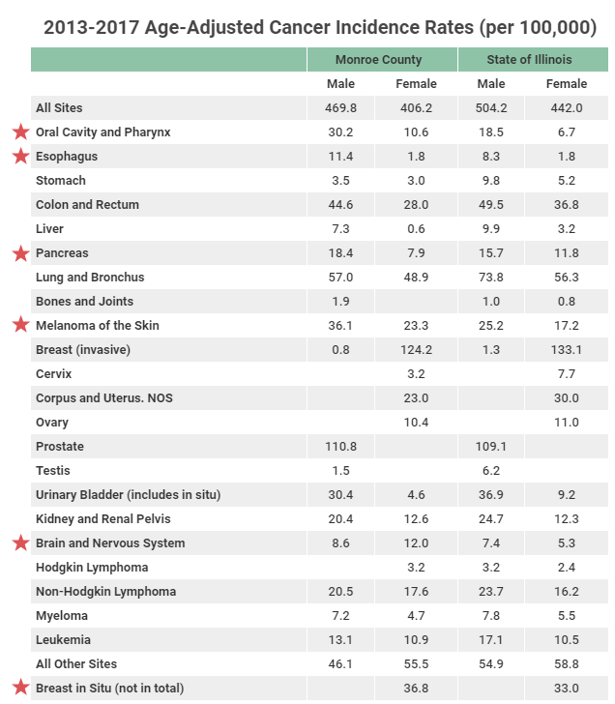
Heart Disease
As of 2019, the leading cause of death were diseases of the heart. Heart disease has remained the leading cause of death in the county since 2013, with the exception of cancer in 2015 (IDPH, 2019).
Cancer
Information for Monroe County cancer rates are from the Illinois County Cancer Statistics Review Incidence by IDPH. 2013-2017 rates are shown to the right and starred areas show a significant increase over state rates. Cancer deaths in the county have been relatively regular from 2013 to 2019. In 2016, there was a dramatic drop in deaths, but since then it has gradually increased. Using the most recent data available, cancer incidence from 2013-2017 included 944 individuals (IDPH, 2019). Cancers most prevalent in Monroe County may be reduced by introducing changes in lifestyle choices, education, and intervention techniques that target those at high risk. Encouraging habits such as healthy eating and proper protection from the sun may make an impact on cancer rates.
Figure 12
Diabetes
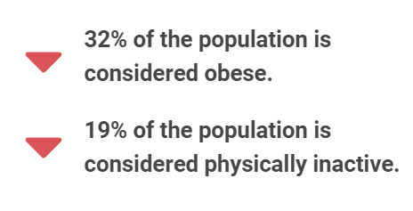
According to the United States Diabetes Surveillance System supported by the CDC, the 2017 diagnosed diabetes percentage for Monroe County was 8.1 for individuals 20 years of age or older, this shows a slight decrease from the 2013 percentage of 8.7. Monroe County still falls below the state average of 10.1% for this year. Diabetes is a growing issue that has become more prevalent in recent decades primarily due to behavioral factors such as poor diet and inactivity.
Obesity
The prevalence of obesity has steadily grown since 2004. The percent of adults that are obese as of 2017 is 32%. This percent is 4 points lower than in 2016 (36%), but aside from this drop off, obesity has continued to grow (County Health Rankings, 2021). 19% of the population is considered physically inactive, a measure that has actually decreased steadily since 2013 (27%). In 2016, Monroe County had less physically inactive people on average than that of the entire State of Illinois (22%). This gives reason to believe that poor eating habits are a larger contributing factor to obesity. Monroe County has relatively few problems in terms of access to exercise opportunities, access to healthy foods, and food insecurity.
Figure 13
Behavioral Factors
As of 2018, the percentage of adults in Monroe County that are current smokers is 17%. This is 1% higher than the average in the State of Illinois, and a 4% increase from the previous four years (13%) (County Health Rankings, 2021). The Illinois Behavioral Risk Factor Surveillance System (BRFSS) (2019) calculated the weighted percent of current smokers from 2015-2019 to be 13.7% and the percent of former smokers to be 26.5%.
Though the county has been deemed relatively healthy compared to others in Illinois, one of its biggest issues is excessive drinking. Based on 2018 data, 24% of the population reported binge-drinking or heavy-drinking. 24% was the highest percentage disclosed out of all Illinois counties, and only two others, McHenry and Woodford reported the same number (County Health Rankings, 2021).
Chronic disease remains a pressing issue that is in dire need of attention. Particularly, introducing healthier lifestyles would be one of the most effective changes in reducing the incidence of cancer, cardiovascular disease, diabetes, and obesity.

Category 5: Infectious Disease
Tuberculosis
All information pertaining to infectious disease was obtained through IDPH. As of 2020, tuberculosis case rates per 100,000 individuals in Monroe County falls at 0. This follows in suit with majority of the counties outside of Chicago and in Southern Illinois. The current rate of new tuberculosis cases per 100,000 individuals in the state of Illinois is 1.69, with Chicago area counties primarily accounting for the bulk of cases (IDPH, 2020).
Hepatitis C
Hepatitis C numbers have remained relatively low in the past decade with 13 cases in 2012, 19 in 2014, and 15 in 2016. The county accounts for less than a percent of the State’s totals each year (IDPH, 2019).

Sexually Transmitted Diseases (STDs)
Communicable disease reports for 2015-2019 show an increase in chlamydia cases. There were 61 reported cases 2015, which has gradually increased (with the exception in a slight drop in 2018) and as of 2019 Monroe County has reached a total of 75 reported cases (IDPH, 2019). Gonorrhea rates have stayed relatively stable since 2015, however the number of new cases per year peaked most recently in 2019 with 16 new cases. In 2014, Monroe County had one case of syphilis. This illness has seen marginal growth and there have only been two more reported cases since then, one in 2016 and another in 2019 (IDPH, 2019). Improving high school sex education programs would provide better knowledge about STD prevention.
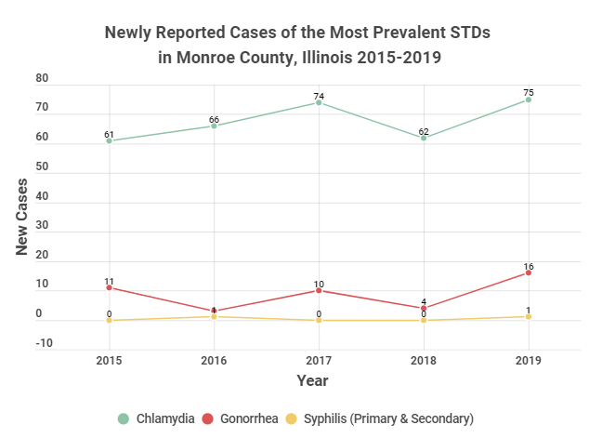
HIV and AIDS cases remain low in the county. A 2020 report shows that there have been 4 diagnosed cases of HIV and 1 diagnosed case of AIDS since 2013 a rate of 1.7 and .4 per 100,000 individuals, respectively. As of March of 2020, there are 10 individuals living with HIV and 9 living with AIDS in the county.
Figure 14
Immunizations
According to the Illinois Comprehensive Automated Immunization Registry Exchange (ICARE), vaccination rates as of 2021 were higher for children age 24-35 months than that of adolescents ages 13-17 years old. The average percent of children 24-35 months old that have received appropriate vaccines for their age group is 67.46%. These vaccines include DTaP 4+, Polio 3+, MMR 1+, Hib UTD, Birth Dose Hep B, Hepatitis B UTD, Varicella 1+, PCV UTD, Rotavirus UTD, and Hepatitis A 2+. This rate is substantially lower than the Healthy People Goals for 2020, which range from 85-90%. The average percent of adolescents age 13-17 years old that have received appropriate vaccines for their age group is 40.3%. These vaccines include Tdap 1+, Polio UTD, MMR 2+, Hep B UTD, Varicella 2+, MEN UTD, MCV4 1+, MCV4 2+, HPV 1+, HPV UTD, and Hep A 2+. The rate of adolescents that have received appropriate vaccines is significantly lower than the Health People Goals of 2020, which range from 80-90%. Data for immunizations may not be representative of the entire county, since many individuals receive their vaccinations from other healthcare providers, which in turn may not be input into the ICARE system. Regardless, the health department must be diligent in informing citizens and providing access to immunizations for children to assure these numbers do not continue to decline. More efforts need to be addressed to ensure compliance with immunization requirements, as all children will need to meet the standards for entrance to school.
Though not a rampant issue, STD prevention and proper immunization are a couple of factors that need to be improved upon in Monroe County. Better education for both children and parents would be the biggest contributor to getting timely vaccinations and practicing safe sex.

Category 6: Environmental/Occupational/Injury Control
Motor Vehicle Accidents
According to the Illinois Department of Transportation (IDOT), in 2018 there were 636 reported crashes in Monroe County, 5 of which were fatal and 140 which caused injury. 75% of these accidents occurred in clear weather conditions, giving reason to believe that some sort of distraction was the cause of the accident rather than environmental factors. The total number of crashes each year has remained relatively stable with 595 in 2017, 644 in 2016, and 639 in 2015. In 2018, one of the deaths involved was considered an alcohol-impaired death (County Health Rankings, 2021). 4.5% of crashes were influenced by individuals under the influence of drugs or alcohol.
The majority of accidents in the county were from rear-end collisions (22.3%). Many of these collisions are likely due to driver attention or lack of, whether it be from cell phone use or other distractions. The bar graph and pie chart below show the age of drivers involved in wrecks as well as the type of accidents in Monroe County in 2018 (IDOT).
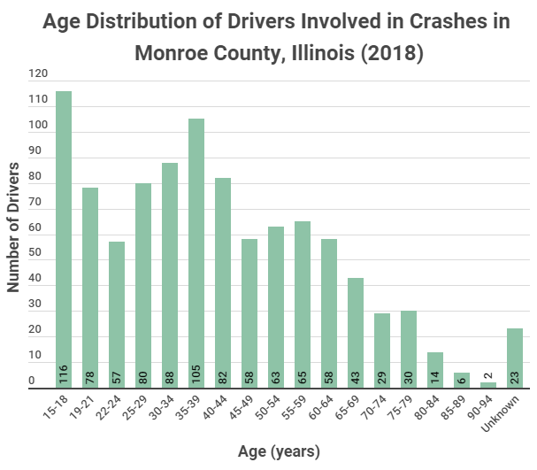

Figure 15
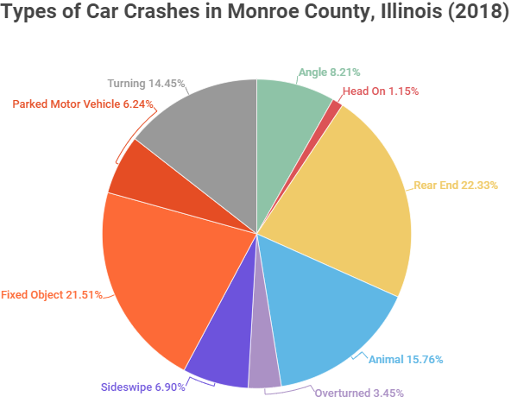
Figure 16

Water and Sewage
Monroe County consists of two primary population centers, Waterloo and Columbia, and three secondary population concentration points, Valmeyer, Hecker and Maeystown. All of these areas are served by municipal water supply and sewage disposal. There are populations in the county that are also served by private sewage disposal and private water wells. In the in the late 1990’s through early 2000’s there was a dramatic increase in the extension of rural water lines in the western part of the county. Since that time additional waterline extensions have been minimal.
The western half of Monroe County consists of Karst topography. This is an environmentally sensitive area where ground water is prone to contamination by unsafe surface practices. The health department commits a significant amount of time and resources to protect this specific type of area.

Lead Exposure
Illinois has one of the highest blood lead levels in children in the entire nation. In 2017, a total of 176 children had their blood lead levels tested and 3.6% of tests confirmed elevated blood level cases ≥5 μg/dL and 1.6% confirmed cases ≥10 μg/dL. This is higher than the state average of 1.3% ≥5 μg/dL and .4% ≥10 μg/dL (IDPH, 2017). Better prenatal education could help lower these numbers and reduce the harm caused to young children in Monroe County.
Injury
As previously mentioned, the reported suicide rates have been relatively steady, with no drastic change in the past decade. According to the IQuery system maintained by IDPH, in 2019 there were 3 reported suicides, 2018 (4), 2017 (3), 2016 (4), 2015 (5), 2014 (3), 2013 (5), 2012 (3), 2011 (3), 2010 (1). Suicide has risen slightly since the early 2010s, but has remained relatively stagnant more recently. From 2015-2019, there were 90 reported injury deaths per 100,000 individuals (County Health Rankings, 2021). Recent statistics on violent crime, reported homicide, rape, and other offenses are unavailable.

Category 7: Sentinel Events
Accurate information specific to Monroe County on sentinel events and adverse healthcare events have not been obtained. However, with no hospital within county borders, little to no reported sentinel events are as expected. According to the Illinois Health and Hospital Association (2016), the Illinois Adverse Health Care Events Reporting Law of 2005 seeks to facilitate open communication and reporting of adverse healthcare events, and although updated in 2016, no comprehensive report for the State of Illinois has been released.

- Priorities
The three priorities, COVID-19, cancer (oral cavity, pharyngeal, and esophageal), and cardiovascular disease (CVD) were chosen based on a survey (see appendix E) completed by residents of the county and in conjuction with professional guidance from the board of health. The survey listed various health topics that affect the community and instructed participants to rank them on a scale of 1 to 10 according to importance. 131 individuals responded to the survey, a substantial amount considering the communication barrier brought on by the COVID-19 pandemic. A response rate could not be obtained. Community representation may be an issue as a majority of the responders were primarily 60 years old or older, however with the age distribution in Monroe County progressively becoming older any biases present may not be as conflicting as they typically would be. The Board of Health met to discuss the feasibility of the results and finalized the three priorities chosen.

Community Health Plan
Introduction
The purpose of the Community Health Needs Plan (IPLAN) is for the Monroe County Health Department to prioritize the health needs of the community. After the community assessment and survey was completed, a series of open meetings were held to discuss the most significant health issues affecting the county. The top three health priorities for Monroe County are COVID-19, cancer (oral cavity, pharyngeal, and esophageal), and cardiovascular disease (CVD). Work groups were developed to look in more detail at each priority. Work sheets were completed and are provided in appendix A, B, and C. The information obtained from these meetings, combined with subsequent meetings with the Board of Health, and the public will be used to guide the Health Department for the next five years.
Funding from the state will likely have a significant impact on the ability of the Health Department to expand services beyond the basic requirements of existing programs. In terms of the current funding situation, any large expansion of services may have the potential to hinder the efficacy of the core programs. Additional funding opportunities will be examined and any services that can be paid with new funding will be considered.
With guidance from the Board of Health and the public, the three health priorities deemed most important in Monroe County have been addressed, and goals and solutions follow to constitute the 2022-2027 IPLAN.

COVID-19
On March 11 of 2020 the World Health Organization declared the SARS-CoV-2 outbreak (COVID-19) a pandemic. According to Johns Hopkins COVID Resource Center (2021), there have been over 170 million cases and over 3.5 million deaths. In the United States alone, half a million have died. As of June 2021, over a year since the pandemic was declared, there have been 4,300 cases in Monroe County, with 94 individuals succumbing to the disease. Although most have recovered, the long term side effects of the virus have not been fully understood, and controlling the spread of COVID-19 is an expected priority of health officials and residents in the county.
COVID symptoms are expansive and variable. Symptoms include, fever, chills, cough, shortness of breath, fatigue, muscle and body aches, loss of taste or smell, headache, sore throat, congestion, nausea, vomiting, diarrhea. Symptoms such as difficulty breathing, chest pain, confusion, inability to stay awake, and sudden skin paleness or blueness require medical attention and may lead to a medical emergency (CDC, 2021).
Typically, only individuals that are hospitalized for COVID-19 are in need of treatment. The U.S. Food & Drug Administration (FDA) states that Veklury (remdesivir), an antiviral medication, is effective in treating pediatric patients. Monoclonal antibody therapy is also used to treat both mild and severe cases of COVID-19 (2021). Corticosteroids have also been used, and ongoing research to find more effective means to treat severe cases of COVID-19 has continued.
COVID-19 can affect anyone despite age, sex, and ethnicity, however, with any disease some individuals are more prone to severe cases than others. Per the CDC (2021) and in no particular order, this includes:
- Individuals age 65 or above.
- Individuals that face long-standing systemic health and social inequities.
- Preexisting medical conditions including but not limited to:
- Cancer
- Chronic Kidney Disease
- Chronic Lung Diseases (COPD, Asthma, Interstitial lung disease, cystic fibrosis, and pulmonary hypertension)
- Dementia or other neurological conditions’
- Diabetes
- Down Syndrome
- Heart Conditions (heart failure, coronary artery disease, cardiomyopathies, hypertension)
- Individuals who are immunocompromised
- Liver Disease
- Individuals who are overweight or obese
- Pregnancy
- Individuals who smoke or have smoked
- Solid organ or blood stem cell transplant recipient
- Stroke or cerebrovascular disease
- Individuals with substance use disorders
Vaccines against COVID-19 were first approved in mid-December, 2020. According to the United States Department of Health & Human Services (HSS), the FDA issued emergency use authorization (EUA) for the Pfizer-BioNTech vaccine for individuals 16 years old or older on December 11th 2020 and 12-15 on May 10th 2021, and Moderna for individuals 18 years old or older on December 18th 2020. The EUA for Janssen was issued on February 27th of 2021 for individuals 18 years or older.
The Monroe County Health Department administered its first COVID-19 vaccine on December 23rd of 2020, and as of June 2021 has administered approximately 17,600 doses, resulting in approximately 8,600 fully vaccinated individuals.
Although the Monroe County Health Department has distributed vaccine in an efficient and timely manner, there is still much concern for the public. Some individuals have chosen to not receive the vaccine, so they are still at risk of getting the virus. Additionally, the vaccine is not 100% effective, so although the risk of contracting the virus is decreased it is not erased. New variants are constantly emerging and depending on the vaccine, effective protection may not be possible. More recently, restrictions have been lifted, but prior to this COVID-19 guideline adherence was a prevalent issue in the county.
Since COVID-19 emerged in late 2019 there are no Healthy People 2030 Objectives specific to the virus. However, COVID-19 does fall into a few categories that pertain to mitigating the spread of the virus. These objectives include:
- HC/HIT-D01: Increase the number of state health departments that report using social marketing in health promotion and disease prevent programs.
- HC/HIT-R01: Increase the health literacy of the population.
- IID-D03: Increase the proportion of adults age 19 years or older who receive recommended age-appropriate vaccines.
By providing Monroe County residents with accurate and relevant information regarding COVID-19 as well as pushing the effort to vaccinate individuals who want the vaccine, the number of new infections should decrease and thus, the overall health and well-being of the community should increase.

Health Problem: Number of COVID-19 infections present in Monroe County residents.
Outcome Objective: Reduce the number of new COVID-19 cases to 800 (25% of cases present in 2020) through 2027.
  - Impact Objective 1: By 2027, get 60% of the eligible population in Monroe County fully vaccinated against COVID-19 (including boosters).
  - Impact Objective 2: By 2027, increase health literacy in regards to COVID-19 through effective social media outreach.

Risk Factors:
- Lifestyle Choices:
- Predisposition: age, sex, race
- Negative habits: obesity, smoking, excessive alcohol consumption
- Exposure: Schools, stores, social events
- Guideline Adherence:
- Vaccine perspectives: personal experience/social circle, media, poor education
- Financial insecurity: failing businesses, lack of resources, job loss/retention
- Public opinion: government attitudes, health attitudes, religious attitudes

Intervention Strategy: The Monroe County Health Department plans to continue encouraging COVID-19 vaccinations as well as promote accurate information regarding the virus on social media sites such as Facebook and the department’s website. The health department will work with the State of Illinois and partner with organizations to offer incentives to those who have chosen to be vaccinated. The health department will also continue to post information on the website and Facebook page to educate the public on news and updates on both the virus itself as well as the vaccine. As booster shots become available, mass vaccination clinics at the county fairgrounds will be held to disperse vaccines in a timely and efficient manner.
In terms of COVID-19 health literacy, concise and comprehensible posts surrounding the virus and vaccine will continue to be made so the public has access to information to guide their decisions regarding vaccines and prospective guideline adherence (as applicable). New online tools such as question and answer sessions and live informational videos will be utilized to draw the attention of the public and increase engagement. Additionally, placing the responsibility of social media posts on an individual health department employee that is proficient in online outreach methods will be vital in determining the most effective health communication strategies and capturing the public’s interest.

Measuring Success: The health department will continue to use the Illinois’ National Electronic Disease Surveillance System (I-NEDSS), as required, to monitor and track new COVID-19 cases. Using I-NEDSS to track new cases will enable the health department to analyze the effectiveness of the solutions presented. ICARE will track the number of COVID-19 vaccines administered and additionally show if vaccination efforts are successful. To track health literacy, using Facebook’s engagement measurement tools and obtaining feedback via surveys on Facebook, the website, and email will serve as means to measure the success of this objective.

Oral Cavity, Pharyngeal, and Esophageal Cancer
Cancer is one of the largest public health concerns that the United States faces. With no universal cure, it has become one of the leading causes of death each year. According to the National Institutes of Health (2020) the rate of cancer incidence in the United States is approximately 442.4 per 100,000 individuals, and the mortality rate is 158.3 per 100,000 individuals. The American Cancer Society (2021) estimates that in 2021 Illinois will have 74,980 new cancer cases and 23,070 deaths. Illinois has a higher incidence rate and death rate than the United States average, 465.5 per 100,000 and 161.7 per 100,000 respectively. Compared to the Illinois average, Monroe County has higher incidence rates of oral cavity, pharyngeal, and esophageal cancer in both men and women, as seen in figure 12. For this reason, it has been deemed a health priority by Monroe County residents and health officials in the county.
Oral cavity, pharyngeal, and esophageal cancer all pertain to the area of the mouth and throat. Using the Surveillance, Epidemiology, and End Result Program (SEER), the 5-year relative survival rate of oral cavity and pharyngeal cancer is 66.9%. The 5-year relative survival rate for esophageal cancer is only 19.9%. Of 27 different types of cancer, the average survival rate is 63.4%. This puts oral cavity and pharyngeal cancer about average in terms of survival rate, and esophageal well below. Out of all of the general cancer diagnoses, pancreatic cancer is the only cancer with a lower survival rate than cancer of the esophagus at, 10.8% (NIH, 2021).
The largest risk factors for oral cavity and pharynx cancer include tobacco use, heavy alcohol use, natural and/or artificial sunlight exposure, and being male (NIH 2019). Although being male is a risk factor for oral cavity and pharyngeal cancer, females in Monroe County additionally have a higher than average risk of developing the disease as well compared to State and National averages. Many of the same risk factors can be attributed to esophageal cancer as well. Tobacco use and heavy alcohol use greatly contribute to esophageal cancer, in addition to old age and Barrett esophagus (a condition in which abnormal cells line the lower esophagus, caused mostly by gastric reflux) (NIH, 2020). As described in the health assessment, Monroe County has higher rates of tobacco and alcohol use compared to the rest of Illinois. Ultimately, the correlation between the prevalence of these risk factors in Monroe County may account for the higher rates of oral cavity, pharyngeal, and esophageal cancer.
The 2018 Illinois Youth Survey for Illinois shows that 26% of 8th graders, 41% of 10th graders, and 60% of 12th graders in Monroe County schools reported drinking alcohol in the last year. Additionally, 14% of 8th graders, 23% of 10th graders, and 46% of 12th graders reported using a tobacco or vape product in the last year. It is imperative to prevent the start of these unhealthy habits, so that it not become a lifelong behavior that may contribute to the development of the specific cancers aforementioned.
The Healthy People 2030 goals that attribute to both oral cavity, pharyngeal, and esophageal cancer that can be used to guide the course of action in Monroe County include:
- OH-07: Increase the proportion of oral and pharyngeal cancers detected at the earliest stage.
- AH-R06: Increase the proportion of schools requiring students to take at least 2 health education courses from grade 6 to 12.
- C-R02: Increase the proportion of people who discuss interventions to prevent cancer with their providers.
- C-11: Increase the proportion of cancer survivors who are living 5 years or longer after diagnosis.
By addressing the risk factors that contribute to oral cavity, pharyngeal, and esophageal cancer, the incidence of new cases should decrease. Increasing the awareness of the harm that smoking and alcohol causes in terms of oral cancers should decrease the number of individuals that partake in such activities. By pushing cessation sentiments, fewer people will smoke and abuse alcohol, and in turn fewer cases of oral cavity, pharyngeal, and esophageal cancer will arise. By reducing these risk factors, not only will quality of life increase directly, but the onset of other diseases, in addition to the targeted cancer will also be prevented.

Health Problem: High incidence of oral cavity, pharyngeal, and esophageal cancer in both men and women in Monroe County.
Outcome Objective: By 2027, reduce the incidence of oral cavity, pharyngeal, and esophageal cancer in Monroe County residents to the State average of 18.5% for men and 6.7% for women.
  - Impact Objective 1: By 2027, reach a 50% drop in the number of students in Monroe County who report using tobacco/vape products (7% for 8th grade, 11.5% for 10th grade, and 23% for 12th grade) and alcohol (13% for 8th grade, 20.5% for 10th grade, and 30% for 12th grade).
  - Impact Objective 2: By 2027, reduce the number of reported smokers in Monroe County from 17% to 12% and binge-drinkers from 24% to 16%.

Risk Factors:
- Lifestyle Choices
- Tobacco use: lack of education in schools, peer pressure, stress
- Obesity: low income, stress, convenience
- Alcohol consumption: lack of education in schools, peer pressure, stress
- Predisposition
- Medical: genetics, disease, lack of resources
- Occupation: exposure, lack of healthcare, stress
- Uncontrollable factors: age, sex, race

Intervention Strategy: The health department must ensure that all schools in Monroe County are in compliance with the Smoke Free Illinois Act (SFIA). According to IDPH, this act prohibits smoking in essentially all public places (2008). Enforcing this would ensure that students and faculty at the very least are not smoking on school property, and places where school-lead events are taking place. The goal in terms of SFIA is to get 85% of all public establishments, including schools, to be smoke-free. Additionally, the health department will make tobacco and alcohol cessation materials (informational pamphlets, support group information, and other resources) available to students and faculty in county schools as well as primary care facilities. Encouraging the use of the Illinois Tobacco Quitline and SAMSHA National Helpline will offer guidance and advice in organizing abstinence from tobacco and alcohol. Finally, using the Botvin LifeSkills Training program (LST) in the classroom setting which aims to reduce tobacco, alcohol, drug use, and violence would be effective means to reduce the frequency of these habits. LifeSkills has been backed by numerous established organizations such as the CDC, NIH, and Coalition for Evidence-Based Policy. LST has specific programs created for different age groups, and the efficacy of these programs are evident.
Aligning with the Healthy People 2030 resources, by having healthcare providers inquire about tobacco use and by having intervention strategies prepared, more successful tobacco cessation is possible. Applying this recommendation made by the U.S. Preventive Services Task Force to alcohol should have a similar outcome. Since factors such as age, sex, and genetic predisposition cannot be altered, behavioral risk factors are the biggest thing that can be changed to reduce the number of oral cavity, pharyngeal, and esophageal cancer rates. Through emphasizing the importance of refraining from alcohol and tobacco in the school setting, the number of individuals that become dependent on these substances will be reduced. The targeted cancer rates, in turn, should decrease as the frequency of these behaviors also decrease.
Measuring Success: Analyzing the results from the Illinois Youth Survey each year will show if the solution proposed is effective. If tobacco and alcohol cessation methods are working, the percent of students that report partaking in activities related to these substances will decrease. Additionally, the health department will ask individuals anonymously through a survey whether they have discussed their health in relation to cancer with their healthcare provider. Data retrieved over the course of the following years will be compared to see whether increased communication has occurred and the solution has been achieved.

Cardiovascular Disease
Cardiovascular disease (CVD) is the leading cause of death in the United States, and in 2019 the disease claimed the lives of over 650,000 individuals (CDC, 2019). In 2020, diseases of the heart accounted for 21% of the total deaths in the state (IDPH, 2020). In Monroe County specifically, heart disease accounted for 23.4% of the total deaths in the county. This rate is on track with the state average, but still work must be done to reduce the number of lives lost to an often preventable disease.

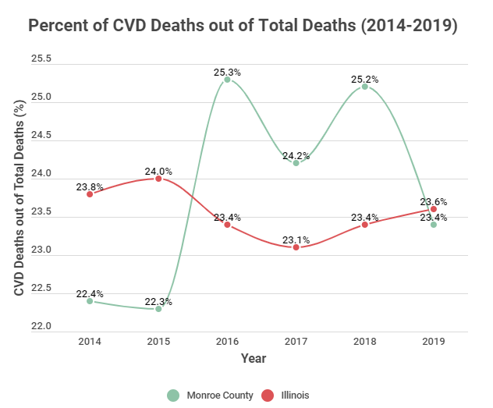
Figure 17

The American Heart Association (2017) states that CVD can refer to various conditions including heart disease, heart attacks, strokes, heart failure, arrhythmia, and heart valve problems. Although each condition is different, many have the same risk factors that contribute to the onset of the disease. Some of the biggest risk factors for CVD include high blood pressure, high cholesterol, diabetes, obesity, heavy drinking and tobacco use, and inactivity (CDC, 2019). CVD does not discriminate against any one race/ethnicity or sex. It is more commonly diagnosed as individuals grow older, however CVD is still the leading cause of death across every other demographic.

The Healthy People 2030 goals that will be used in addressing CVD in Monroe County include:
  - HDS-01: Improve cardiovascular health in adults.
  - NWS-04: Reduce the proportion of children and adolescents with obesity.
  - NWS-03: Reduce the proportion of adults with obesity.
  - HDS-06: Reduce cholesterol in adults.
Many conditions predispose one to developing some sort of CVD. By targeting diabetes and obesity (and in turn high blood pressure and high cholesterol), the incidence and deaths related to CVD should decline. Promoting exercise and use of local facilities throughout the county should cause an increase in physical activity. Offering guidance for those with diabetes or at risk for developing diabetes should encourage individuals to make informed decisions about their behavior and lifestyle as well as spark proactive communication between patients and their healthcare providers.

Health Problem: Number of CVD related hospitalizations ad death in Monroe County, Illinois.
Outcome Objective: By 2027, get the number of CVD deaths in the county down to 20% and the hospitalization rate per 1,000 individuals down to 55.
  - Impact Objective 1: Reduce the percent of individuals with diagnosed diabetes down to 7.2% by the year 2027.
  - Impact Objective 2: Reduce the percent of the population in the county that is considered obese to 28% by 2027.

Risk Factors:
- Lifestyle Choices
- Obesity: cheap food, convenience, stress
- Lack of exercise: lack of time, lack of opportunity, difficulty
- Smoking and drinking: stress, peer pressure, lack of education
- Predisposition
- Medical conditions: family history/genetics, high blood pressure, diabetes
- Occupation: stress, exposure, high intensity jobs
- Uncontrollable factors: age, sex, race

Intervention Strategy: Physical inactivity is a huge factor contributing to obesity. With technology constantly evolving, the use of local parks and playgrounds has decreased. The health department, schools, and other organizations should stress the importance of staying active. Instilling this mindset in children as they are growing up would potentially make regular exercise a habit, and reduce the number of individuals that are overweight or obese. Since all the parks in Monroe County are municipalities, constructing a county park would put responsibility in the hands of county officials. Outdoor exercise equipment would be included to encourage intentional exercise for individuals of all ages. Signs explaining the importance of exercise would be placed around the park for individuals to view.
Additionally, creating a diabetes outreach program would be beneficial in making individuals aware of the danger of diabetes. Regular posting on the Facebook page and website would reach a large amount of individuals living in the county. Showing the link between diabetes and CVD (as well as other diseases) would prompt individuals to be proactive about their health. Providing informational materials on these platforms would also engage the public. Encouraging communication between patients and healthcare providers is also a vital step, since specialized information catered to each individual can be obtained through them.
Measuring Success: Measuring success of these two solutions is a bit more difficult and will rely heavily on feedback from the community. As with all the other solutions proposed, a survey will be the best means of determining the efficacy of both plans.

Conclusion
As described, COVID-19, cancer (oral cavity, pharyngeal, and esophageal), and cardiovascular disease will be the focus points for the following five years. Mitigating these issues will rely heavily on open communication that is focused on reaching various population groups in the county. Monroe County residents must understand the importance of being proactive and taking action in terms of their health. Encouraging feedback from county residents on their health experiences will also serve as the best means of tracking the progress of the planned solutions. The IPLAN for Monroe County will help guide the health department on addressing the established areas of concern and in turn improve the quality of life in the county.

Appendix A
Community I-Plan Meeting Roster
Monroe County Health Department
Gateway Urgent Care
SSM Healthcare
Human Support Services
Waterloo Police
Monroe County Sherriff
Retired Nurses Association
Oakhill Nursing Home
Monroe County Commissioners
Monroe County Citizens

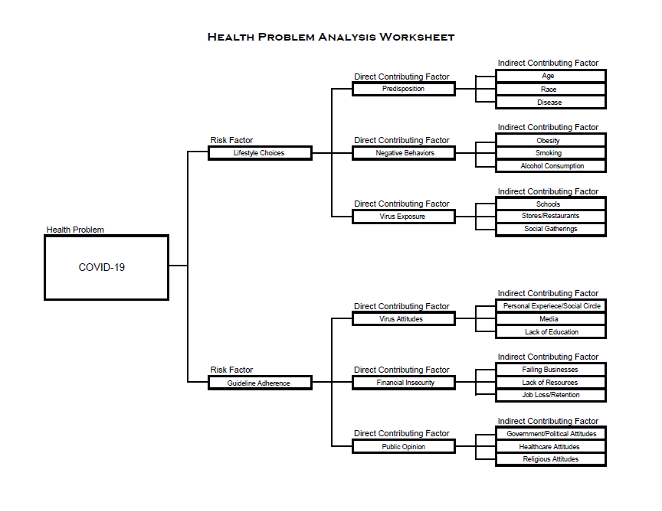
Appendix B
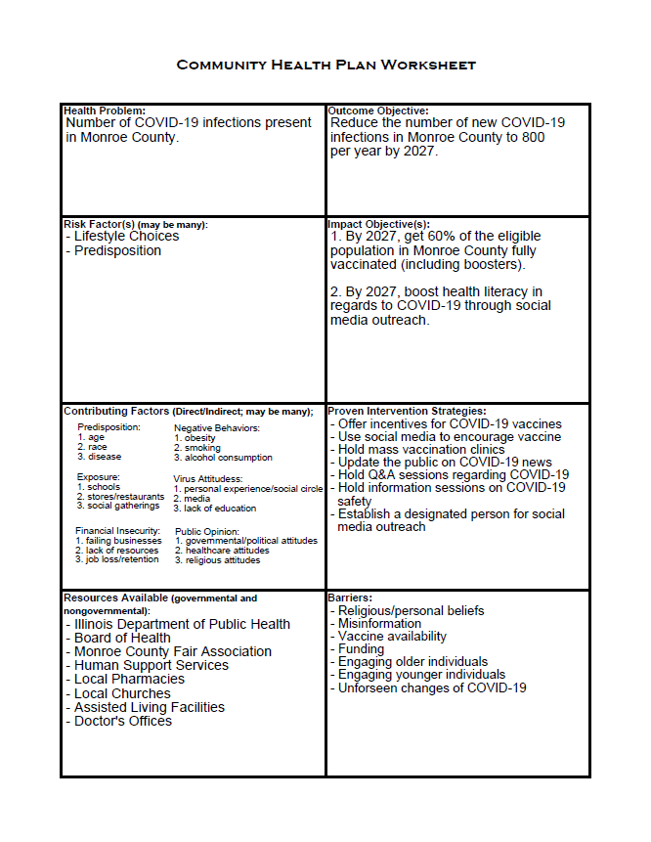

Appendix C
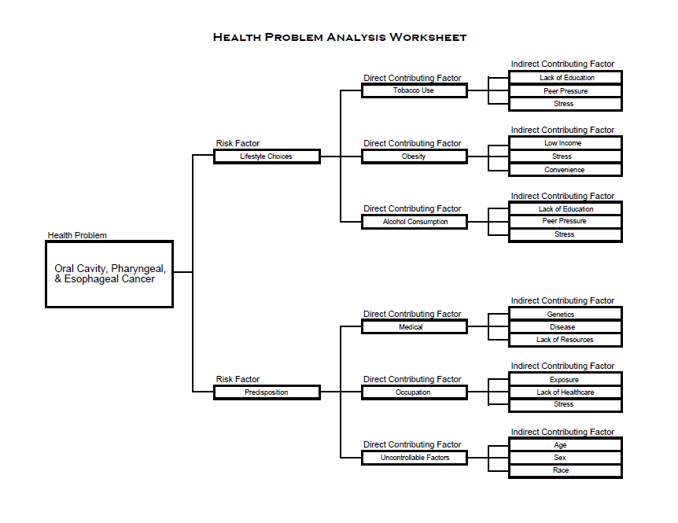
Appendix D
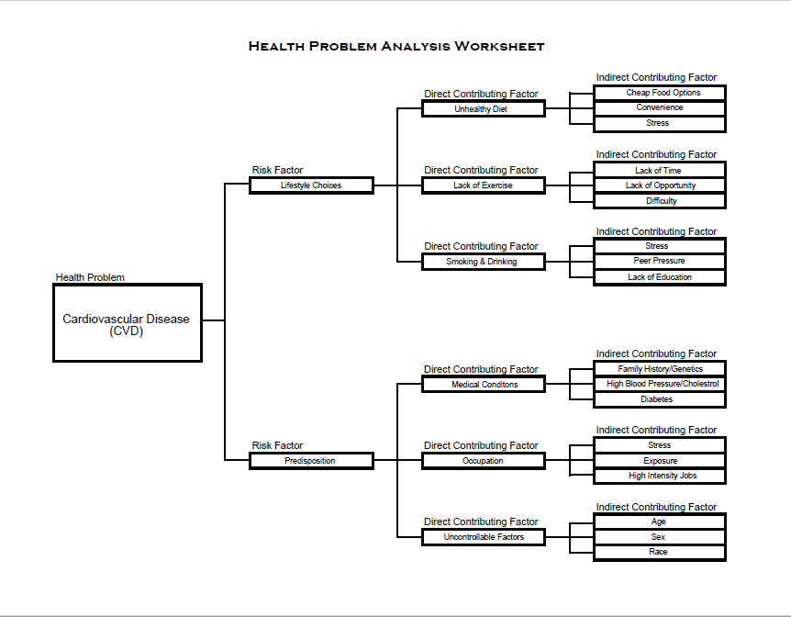
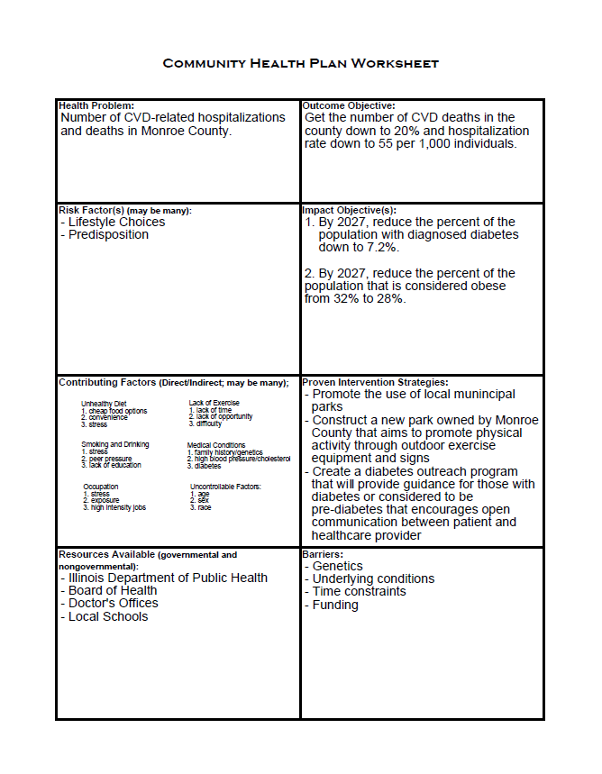
Appendix E
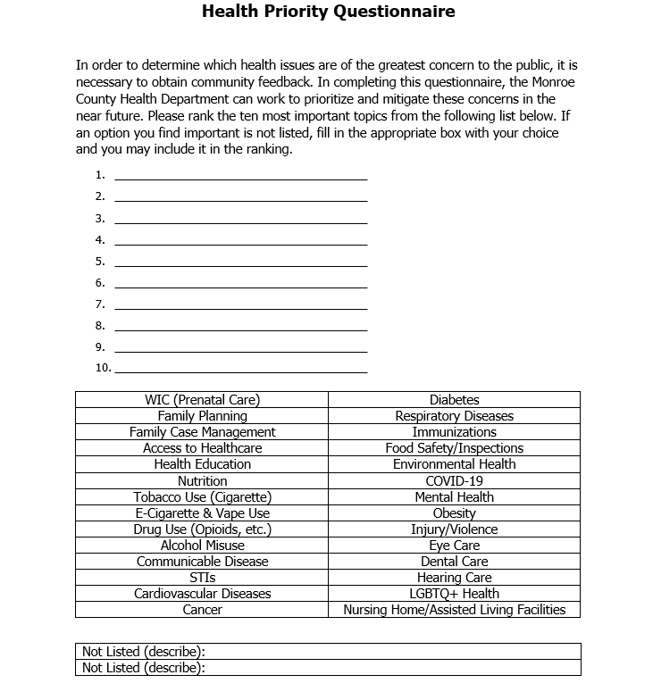

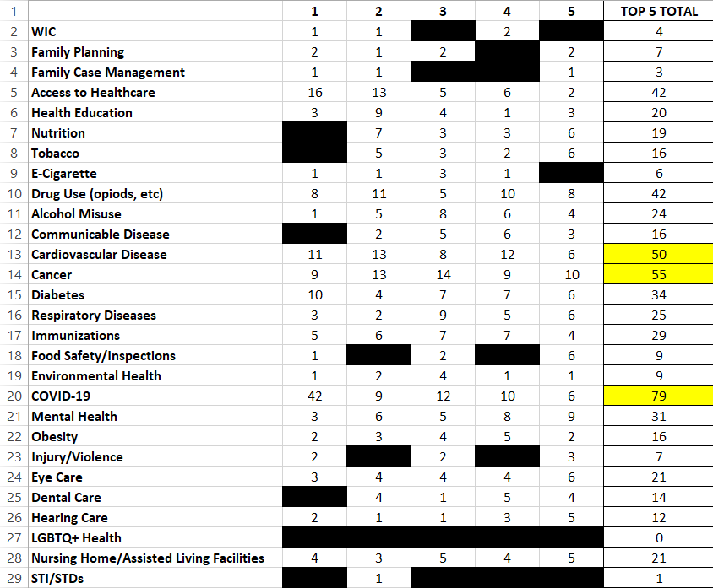

References:

American Community Survey. (2019). Monroe County, Illinois: Weekly Average Working Hours Change. https://data.floridatoday.com/american-community-survey/block-group-1-census-tract-600402-monroe-county-illinois/labor-statistics/average-working-hours/yty/15000US171336004021/
American Heart Association. (2017). What is Cardiovascular Disease? https://www.heart.org/en/health-topics/consumer-healthcare/what-is-cardiovascular-disease
Botvin LifeSkills Training. (n.d.). LST Overview. https://www.lifeskillstraining.com/lst-overview/
Census Reporter. (2019). Profile: Monroe County, Illinois. https://censusreporter.org/profiles/05000US17133-monroe-county-il/
Centers for Disease Control and Prevention. (2017). Diagnosed Diabetes. United States Diabetes Surveillance System, Division of Diabetes Translation. https://gis.cdc.gov/grasp/diabetes/DiabetesAtlas.html#
Centers for Disease Control. (2019). Know Your Risk For Heart Disease. https://www.cdc.gov/heartdisease/risk_factors.htm
Centers for Disease Control. (2019). Leading Causes of Death. National Center for Health Statistics. https://www.cdc.gov/nchs/fastats/leading-causes-of-death.htm
Centers for Disease Control and Prevention. (2021, Feb). Symptoms of COVID-19. https://www.cdc.gov/coronavirus/2019-ncov/symptoms-testing/symptoms.html
County Health Rankings & Roadmaps. (2021). Monroe County, Illinois. https://www.countyhealthrankings.org/app/illinois/2021/rankings/monroe/county/factors/overall/snapshot
Federal Reserve Bank of St. Louis. (2021). Net County-to-County Migration Flow (5-year estimate) for Monroe County, IL. Federal Reserve Economic Database. https://fred.stlouisfed.org/series/NETMIGNACS017133
Houston-Kolnik, J., Kirkner, A., Guharay, R., & Hiselman, J. (2019, October 17). Domestic Violence Trends in Illinois: Victimization Characteristics, Help-Seeking, and Service Utilization. Illinois Criminal Justice Information Authority & Center for Victim Studies. http://www.icjia.state.il.us/assets/articles/DomesticViolenceTrends_Victim_HelpSeeking_Services_10_17_19_Final-191022T20363236.pdf
Illinois Comprehensive Automated Immunization Registry Exchange. (2021, June). Coverage Level Adolescent. https://icare.dph.illinois.gov/icare2/Report/CoverageLevel/Adolescent/Pdf
Illinois Comprehensive Automated Immunization Registry Exchange. (2021, June). Coverage Level Childhood. https://icare.dph.illinois.gov/icare2/Report/CoverageLevel/Childhood/Pdf
Illinois Department of Employment Security. (April, 2021). Illinois Unemployment Rate by County. Illinois Department of Employment Security, Economic Information & Analysis Division. https://www2.illinois.gov/ides/lmi/local%20area%20unemployment%20statistics%20laus/countymap.pdf
United States Department of Health & Human Services. (2021). COVID-19 Vaccine Distribution: The Process. https://www.hhs.gov/coronavirus/covid-19-vaccines/distribution/index.html
Illinois Department of Healthcare and Family Services. (2020). Number of Persons Enrolled in Monroe County. https://www.illinois.gov/hfs/info/factsfigures/Program%20Enrollment/Pages/monroe.aspx
Illinois Department of Public Health. (2018). 2018 Birth Statistics. https://dph.illinois.gov/data-statistics/vital-statistics/birth-statistics
Illinois Department of Public Health. (2018). Birth Characteristics by Resident County, Illinois Residents, 2018. https://dph.illinois.gov/sites/default/files/Birth%20characteristics%20201820200304.pdf
Illinois Department of Public Health. (2019). County Level Prevalence Data: Tobacco & E-Cigarettes. Illinois Behavioral Risk Factor Surveillance System. http://www.idph.state.il.us/brfss/countydata.asp?selTopicCounty=Tobacco&areaCounty=Monroe_67&show=freq&yrCounty=6&form=county&yr=&area=&selTopic
Illinois Department of Public Health. (2020). Death Statistics. https://www.dph.illinois.gov/data-statistics/vital-statistics/death-statistics
Illinois Department of Public Health. (n.d.). Description of Illinois Project for Local Assessment of Needs (IPLAN). http://app.idph.state.il.us/docs/iplan.htm
Illinois Department of Public Health. (2016). Hepatitis C, chronic. IQuery. https://iquery.illinois.gov/DataQuery/Default.aspx
Illinois Department of Public Health. (2020, March). HIV/AIDS Monthly Surveillance Update. HIV/AIDS Section. http://dph.illinois.gov/sites/default/files/HIV_AIDS_Monthly_Surveillance/HIV%20AIDS%20MONTHLY%20SURVEILLANCE%20UPDATE%202020_03.pdf
Illinois Department of Public Health. (2019, February). Illinois Lead Program 2017 Annual Surveillance Report. https://www.dph.illinois.gov/sites/default/files/publications/lead-surveillance-report-2017-20.pdf
Illinois Department of Public Health. (2010). Illinois Population Data. https://dph.illinois.gov/data-statistics/vital-statistics/illinois-population-data
Illinois Department of Public Health. (2020). Illinois Tuberculosis Case Rates per 100,000 Population 2020. http://www.dph.illinois.gov/sites/default/files/publications/2020-tb-rate-maps.pdf
Illinois Department of Public Health. (2019). Leading Causes of Death. IQuery. https://iquery.illinois.gov/dataquery/REPORT_HealthEvents.aspx?ReportTypeID=2&ReportID=11&ReportName=Leading+Causes+of+Death
Illinois Department of Public Health. (2019). More Detailed Birth Statistics. https://www.dph.illinois.gov/data-statistics/vital-statistics/birth-statistics/more-statistics
Illinois Department of Public Health. (2019). Number of Deaths by Resident County, Illinois Residents 2010-2019. https://www.dph.illinois.gov/sites/default/files/Deaths%20by%20county%202010-2019.pdf
Illinois Department of Public Health. (2019). Reportable Sexually Transmitted Diseases by Morbidity Responsibility Area. http://dph.illinois.gov/sites/default/files/publications/2020-12-std-county-comp-and-demo.pdf
Illinois Department of Public Health. (2008). Smoke-free Illinois. http://www.smoke-free.illinois.gov/index.htm
Illinois Department of Public Health. (2016). Teen Births by Resident County, Illinois Residents, 2016. https://dph.illinois.gov/sites/default/files/publications/Teen-Births-by-County-2016.pdf
Illinois Department of Transportation. (2018). County Summary Crash Report. Division of Traffic Safety. http://apps.dot.illinois.gov/eplan/desenv/crash/County%20Summaries/Year%202018/Monroe%202018.pdf
Illinois Health and Hospital Association. (2016, May). Reporting Law Summary: Illinois Adverse Healthcare Events Reporting Law of 2005. https://www.team-iha.org/quality-and-safety/advocacy-connections/illinois-adverse-events-reporting-law/il-adverse-health-care-events-reporting-law-summar
Illinois Youth Survey. (2018). 2018 County Report: Monroe. University of Illinois. https://iys.cprd.illinois.edu/UserFiles/Servers/Server_178052/File/2018/Cnty18_Monroe.pdf
Johns Hopkins University and Medicine. (2021). Coronavirus Resource Center: COVID-19 Dashboard. Center for Systems Science and Engineering (CSSE). https://coronavirus.jhu.edu/map.html
National Institutes of Health. (2021). Cancer Stat Facts: Common Cancer Sites. National Cancer Institute: Surveillance, Epidemiology, and End Results Program. https://seer.cancer.gov/statfacts/html/common.html
National Institutes of Health. (2020, Nov.). Cancer Statistics. National Cancer Institute. https://www.cancer.gov/about-cancer/understanding/statistics
National Institutes of Health. (2020). Esophageal Cancer Treatment. National Cancer Institute. https://www.cancer.gov/types/esophageal/patient/esophageal-treatment-pdq#Keypoint2
National Institutes of Health. (2019). Lip and Oral Cavity Treatment. National Cancer Institute. https://www.cancer.gov/types/head-and-neck/patient/adult/lip-mouth-treatment-pdq#_1
United States Bureau of Labor Statistics. (2019). County Employment and Wages in Illinois – Fourth Quarter 2019. https://www.bls.gov/regions/midwest/news-release/countyemploymentandwages_illinois.htm#Table2.xlsx.f.1
United States Census Bureau. (2019). Comparative Housing Characteristics: ACS 5-Year Estimates Comparison Profiles. https://data.census.gov/cedsci/table?q=Monroe%20County%20Illinois&t=Homeownership%20Rate%3AHousing%3AHousing%20Units%3AOwner%2FRenter%20%28Householder%29%20Characteristics&tid=ACSCP5Y2019.CP04
United States Census Bureau. (2019). Food Stamps/Supplemental Nutrition Assistance Program (SNAP): Monroe County, Illinois. https://data.census.gov/cedsci/table?q=Monroe%20County,%20Illinois&t=Income%20and%20Poverty&tid=ACSST5Y2019.S2201&hidePreview=true
United States Census Bureau. (2019). QuickFacts: Monroe County, Illinois. https://www.census.gov/quickfacts/fact/table/monroecountyillinois/PST045219
United States Census Bureau. (2018). Small Area Health Insurance Estimates (SAHIE): Insured. https://www.census.gov/data-tools/demo/sahie/#/?s_statefips=17&s_stcou=17133&s_agecat=0&s_measures=ic_snc&s_year=2018&s_iprcat=0&s_sexcat=2
United States Census Bureau. (2018). Small Area Health Insurance Estimates (SAHIE): Uninsured. https://www.census.gov/data-tools/demo/sahie/#/?s_statefips=17&s_stcou=17133&s_agecat=0&s_measures=ui_snc&s_year=2018
United States Census Bureau. (2019). Small Area Income and Poverty Estimates (SAIPE). https://www.census.gov/data-tools/demo/saipe/#/?map_geoSelector=aa_c&s_state=&s_year=2019&s_county=1713
United States Department of Health and Human Services. (2021). Tobacco Smoking Cessation in Adults, including Pregnant Women: Behavioral and Pharmacotherapy Interventions. https://health.gov/healthypeople/tools-action/browse-evidence-based-resources/tobacco-smoking-cessation-adults-including-pregnant-women-behavioral-and-pharmacotherapy-interventions
United States Food & Drug Administration. (2021, Mar). Know Your Treatment Options for COVID-19. https://www.fda.gov/consumers/consumer-updates/know-your-treatment-options-covid-19
vanOstenberg, P. R. (2008). Understanding and Preventing Sentinel and Adverse Events. ICU Management & Practice. https://healthmanagement.org/c/icu/issuearticle/understanding-and-preventing-sentinel-and-adverse-events

