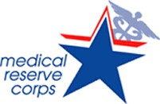

Quarterly Newsletter
Giving Thanks

Monroe County, IL

Welcome to the first quarterly newsletter of the Monroe County, IL MRC Unit #2781
What better time to release our first quarterly newsletter than November, a month for giving thanks.
Thank you to all the volunteers that have previously worked tirelessly during the COVID-19 response and those that have joined our unit since that time. It is through giving that we receive. Thank you for your interest in volunteering to make our county and communities the best that they can be!
Here are some of the accomplishments that have been made within our unit during 2023:
- Applied for and received 2023 NACCHO COVID RISE Award
- Applied for and received 2023 NACCHO ORA Award
- Applied for MRCIL STTRONG Award, approval pending
- Applied for 2024 NACCHO Award, approval pending
- Established a mission statement, organization chart, goals, and objectives for our unit
- Established a Monroe County, IL MRC Facebook account and a link on Monroe County Health Department website
- Purchased 12 laptops and equipped them for future volunteer trainings
- Purchased and stocked backpacks for nurses and non-nurses with supplies for use during deployments
- Purchased a platform for volunteer management, partnering with Monroe County Emergency Management Agency
- Using Illinois Helps for volunteer registration, credentialing, and background checks
- Held a “meet and greet” event on June 27-28, 2023, at Monroe County Health Department to meet volunteers and assist them with onboarding into Illinois Helps and MRC TRAIN
- Offered a CPR/First Aid training on October 6, 2023, partnering with Monroe County EMS
- Manned a table at Columbia EMS open house, Monroe County EMS open house and at the Monroe County Fair
- Purchased MRC labeled tablecloths for use at open houses and community events
- Purchased and labeled with MRC logo a 6 ft. x 12 ft. trailer
- Purchased preparedness guide booklets for volunteers’ use before and during future deployments

Here are some of our plans for 2024:
- Continue to grow and strengthen our volunteer unit
- Continue to work with community partners to create awareness of our volunteer unit
- Develop a Behavioral Health Strike Team of professionals to meet the behavioral and mental health need of our volunteers and public health staff
- Develop training plans to equip our volunteers for future deployment
- Continue to participate in community events to make ourselves visible in the communities we serve
***Please make sure to stay connected with our unit on our Facebook page and Monroe County Health
Department website: https://monroecountyhealth.org/volunteers/

Upcoming Events:
MRCIL Training Summits to be held in 2024: Please sign up at: https://form.jotform.com/232915199698172

Re"MRC"able Training Workshops
These training summits will be held throughout the state of Illinois to be beneficial for all local MRC units and their volunteers. Registration starts at 7:30 a.m., the event starts at 8:00 a.m., and will end at 4:30 p.m.
- November 15, 2023 is in Bolingbrook
  - Hilton Garden Inn: 135 Remington Blvd, Bolingbrook, IL 60440
- December 6, 2023 is in Rockford
  - Radisson Hotel and Conference Center: 200 S Bell School Rd, Rockford, IL 61108
- January 17, 2024 is in Collinsville
  - Gateway Conference Center: 1 Gateway Dr., Collinsville, IL 62234
- February 14, 2024 is in Champaign
  - I Hotel & Illinois Conference Center: 1900 S 1st St, Champaign, IL 61820
- March 20, 2024 is in Macomb
  - Western Illinois University: 1 University Cir, Macomb, IL 61455
- April 10, 2024 is in Carbondale
  - Southern Illinois University, Student Center: 1255 Lincoln Drive, Carbondale IL 62901
There is no cost to these training summits. Lunch is provided at each venue.
​
If there is a cost for parking, we have already worked with the venue ahead of time. There is no cost to you!

Here is the agenda:
We appreciate you!!! The following are tips for how to handle holiday stress (Mayo Clinic):
- Acknowledge your feelings
- Reach out
- Be realistic
- Set aside differences
- Create a budget
- Plan ahead
- Saying “no” is ok
- Keep up healthy habits
- Give yourself a break
- Seek professional help is you need it
More information can be found at: https://mcpress.mayoclinic.org/mental-health/tips-for-taking-control-of-the-holidays-so-they-dont-take-control-of-you
Suggestions/Questions??? Please contact our MRC Unit #2781 Leader at:
Marsha L. Wild MSN RN
Unit Leader
Monroe County MRC
Unit #2781
1315 Jamie Lane
Waterloo, IL 62298
mwild@monroecountyhealth.org
(618) 612-7105

COVID-19 Vaccinations in Monroe County, IL - A Unique Experience
Have you ever administered vaccinations in a horse barn or cave? We have in Monroe County, Illinois!
Initially, COVID-19 vaccinations were administered at the Monroe County Fairgrounds. However, the weather conditions during winter in the Midwest were not the most favorable. Windy conditions, frigid temperatures, sleet, and snow made the task very difficult for the patients, first responders and volunteers. Papers were flying, frosty faces and ice-cold hands were some of the conditions caused by the weather. The decision was made to move indoors to a horse barn at the fairgrounds and ultimately to a cave for safety and comfort.
Ok, some individuals may have administered vaccinations in a horse barn, but a cave? Now, mind you, this is no ordinary cave…
The cave, known as Rock City, was formed 120 years ago when miners were milling high-grade limestone on the bluffs near Valmeyer, IL. The value of the temperature and humidity-controlled space was discovered, and the space has been utilized ever since by private industry as well as the government. Now the space is a subsurface business complex composing approximately 6 million square feet. It provides a constant 58 degrees temperature and even has paved streets and fire hydrants!
During the pandemic, public health and community officials recognized the value of this location to have a drive through COVID-19 vaccination clinic. Thanks to their cooperation and the hard work of first responders and volunteers, the drive-through COVID-19 vaccination clinic in the cave was a huge success in Monroe County, IL.

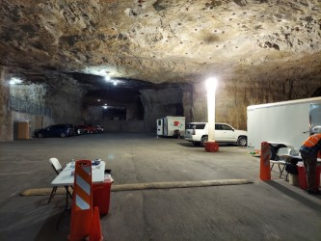
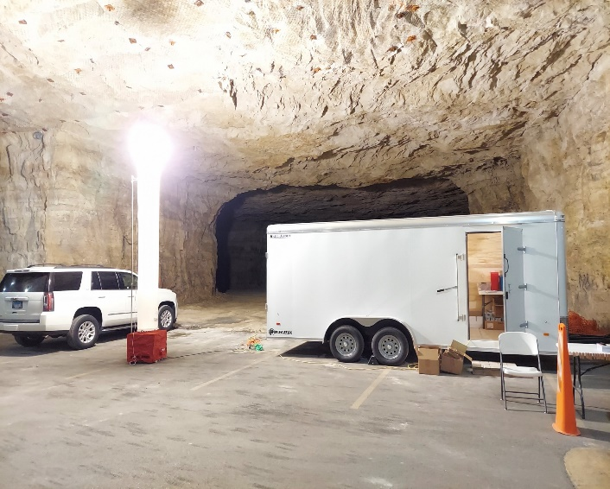
Thank you, Monroe County, IL!!! You got the job done!!!

