Quarterly Newsletter
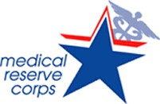
Monroe County, IL

Spring into Action
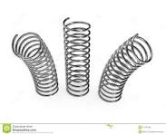
Welcome to the second quarterly newsletter of the Monroe County, IL MRC Unit #2781
Hope you are all staying warm and dry during the winter months and are looking forward to spring!
Here are some of our activities and plans that are ‘springing into action’ for 2024:
- We have been awarded a $10,000 2024 Operational Readiness Award from NACCHO to continue to recruit and strengthen our MRC Unit. We plan to purchase a platform to electronically sign documents for ease in onboarding new volunteers and two freestanding, retractable banners for use at Monroe County Health Department and to take off-site to open houses, fairs, etc.
- We have also been awarded a $5,000 MRCIL (Medical Reserve Corps of Illinois) STTRONG (State, Territory and Tribal Nations, Representative Organizations for Next Generation) Award to focus on re-creating a Behavioral Health Strike Team which could assist during emergencies and behavioral health needs in our community. We hope to provide behavioral health information to public health staff and volunteers also.
- We plan to participate in future Search and Rescue trainings and possibly form a Search and Rescue team for our area. We have been in contact with St. Clair County and Wayne County who are interested in providing the trainings also.
- We are participating with Monroe County Emergency Management Agency (EMA) in a tabletop exercise sometime this year with a focus on earthquake preparedness.
- We plan to continue to participate in community events to make ourselves visible in the communities we serve.
***ATTENTION***
You will be receiving an email soon regarding an in-person, 4-hour presentation provided by Stacey Macchi, Associate Professor at Western Illinois University, who will be providing useful information regarding stress management, anxiety, depression, communication skills and other behavioral health topics. Please try to make every effort to attend this session as it can be valuable for you as a volunteer and in your relationships with family and friends. The presentation will be conducted at Monroe County Health Department. We are open to addressing any behavioral health concerns you may have also and will be sending out a survey prior to the event to collect pertinent information.
There may still be snow on the ground but let's put forth a sunny outlook as we welcome spring with some fun facts:
- Spring fever is a real syndrome.
- Benjamin Franklin was the first to propose daylight savings time in 1784.
- The first day of spring is called the vernal equinox.
Continuing Events:
Eight members of our MRC Unit were able to attend the January 17, 2024 “MRC”able training workshop held at Gateway Conference Center, Collinsville, IL. I think we can agree that it was an enjoyable experience, and we learned lots of new, valuable information!
If you are interested and did not have the opportunity to attend one of the following, here is a list of the remaining dates and locations…
MRCIL Training Summits to be held in 2024: Please sign up at: https://form.jotform.com/232915199698172

Re"MRC"able Training Workshops
These training summits will be held throughout the state of Illinois to be beneficial for all local MRC units and their volunteers. Registration starts at 7:30 a.m., the event starts at 8:00 a.m., and will end at 4:30 p.m.
- March 20, 2024 is in Macomb
  - Western Illinois University: 1 University Cir, Macomb, IL 61455
- April 10, 2024 is in Carbondale
  - Southern Illinois University, Student Center: 1255 Lincoln Drive, Carbondale IL 62901
There is no cost to these training summits. Lunch is provided at each venue. 6.5 free Nursing Continuing Education Units (CEUs) are also available!!!
​
If there is a cost for parking, we have already worked with the venue ahead of time. There is no cost to you!

Here is the agenda:

***Be watching for a “Volunteer Spotlight: segment in our next quarterly newsletter!!!***

Suggestions/Questions??? Please contact our MRC Unit #2781 Leader at:
Marsha L. Wild MSN RN
Unit Leader
Monroe County MRC
Unit #2781
1315 Jamie Lane
Waterloo, IL 62298
mwild@monroecountyhealth.org
(618) 612-7105

Please make sure to keep your contact information current on Illinois Helps at www.illinoishelps.net and to stay connected with our unit on our Facebook page and Monroe County Health Department website: https://monroecountyhealth.org/volunteers/
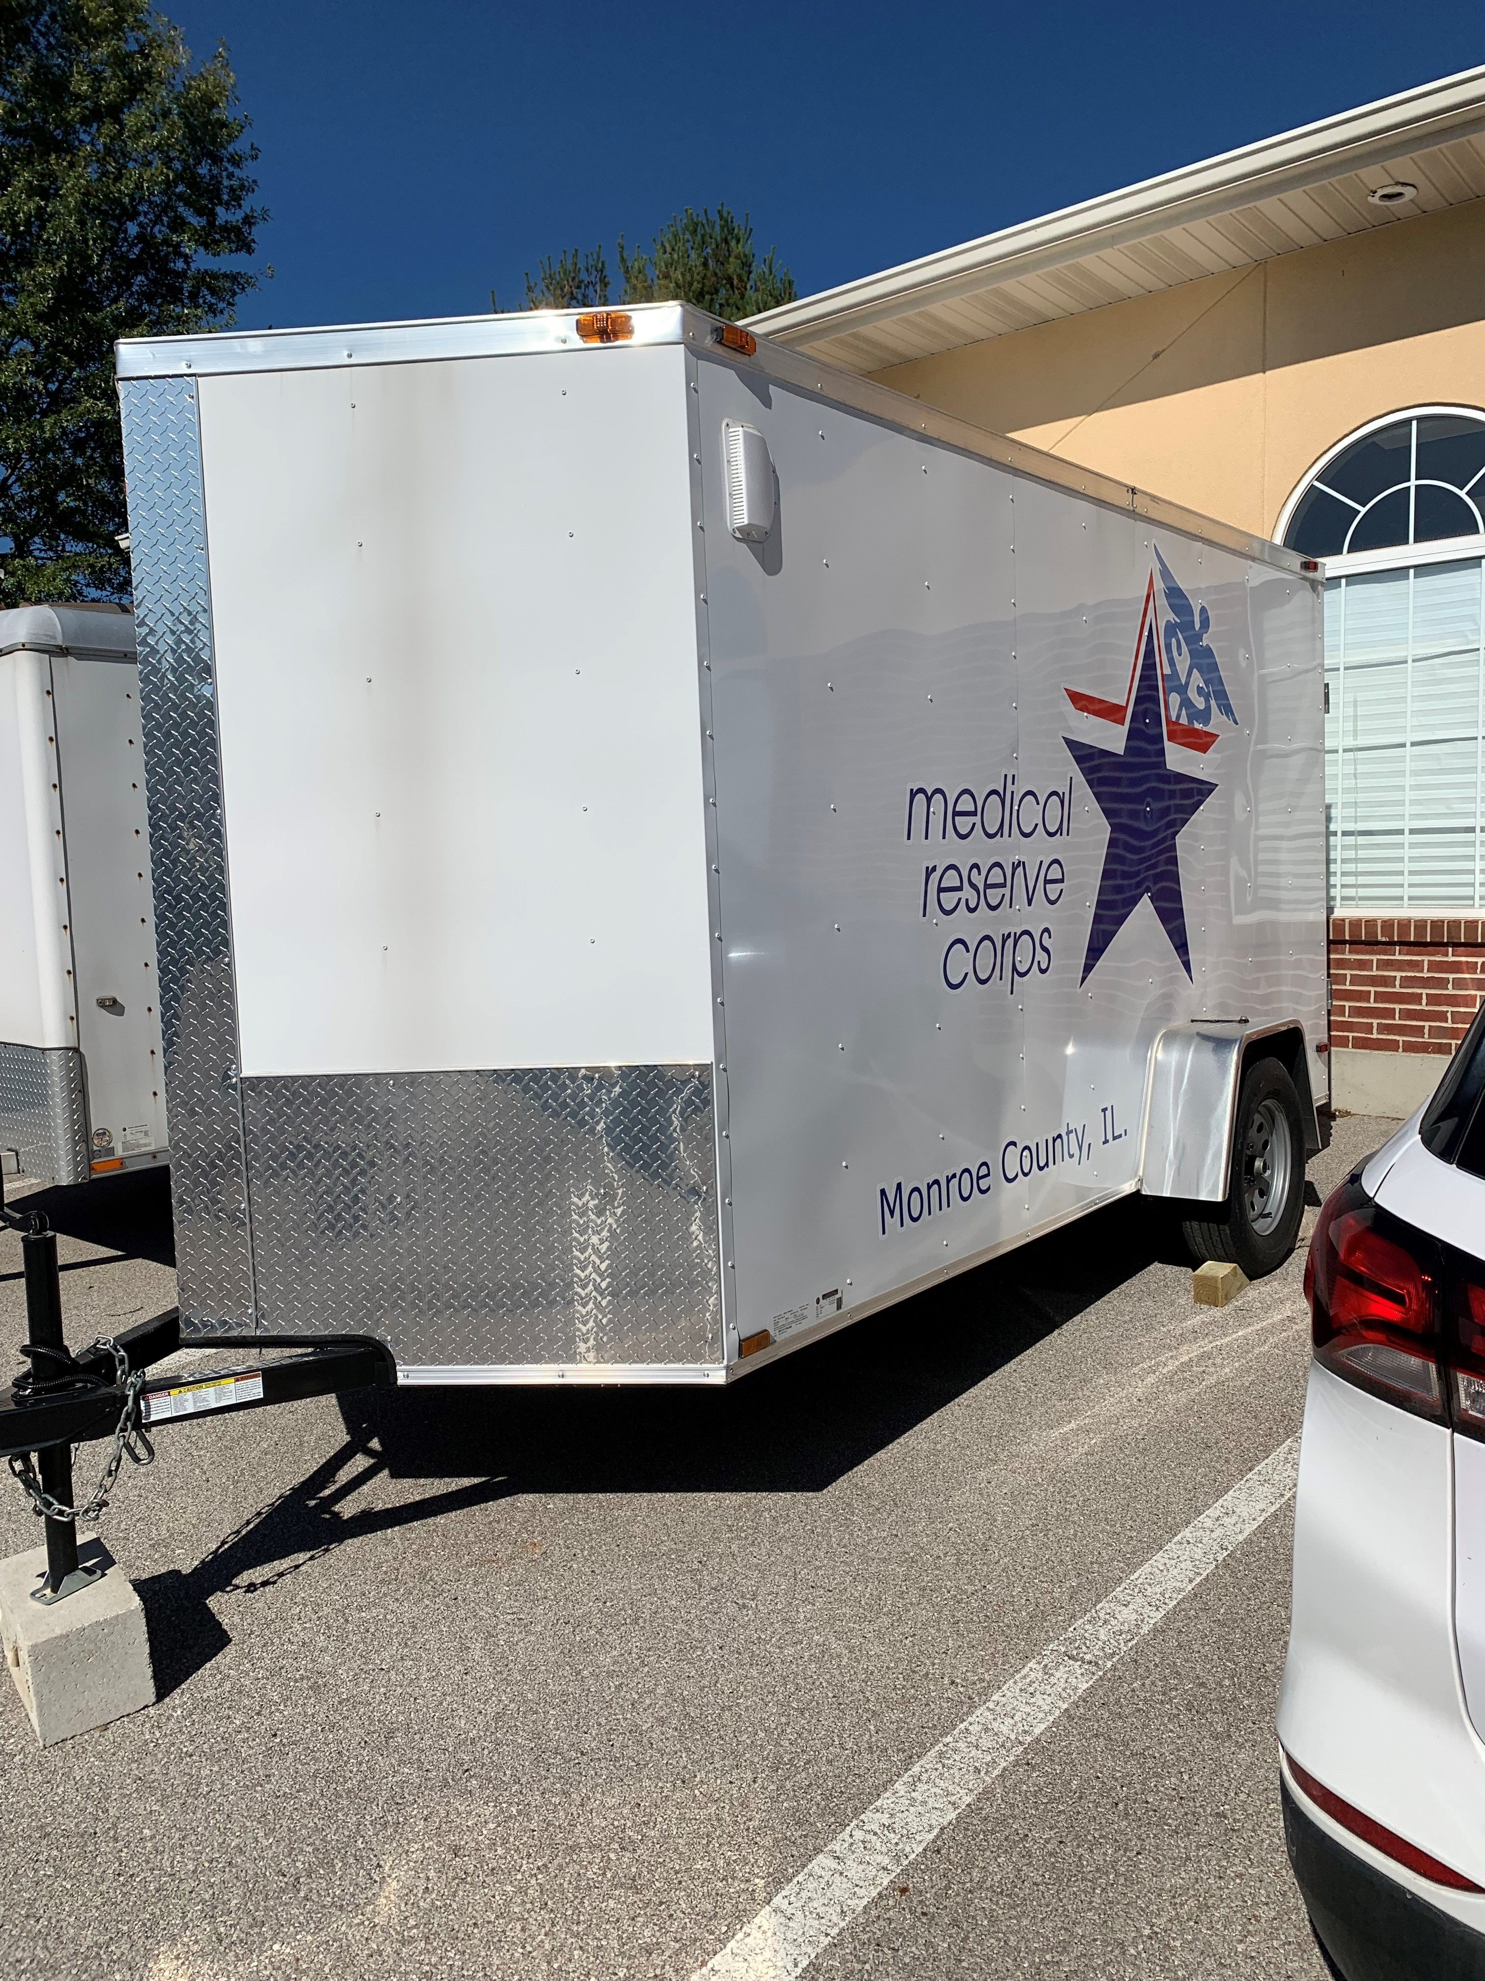

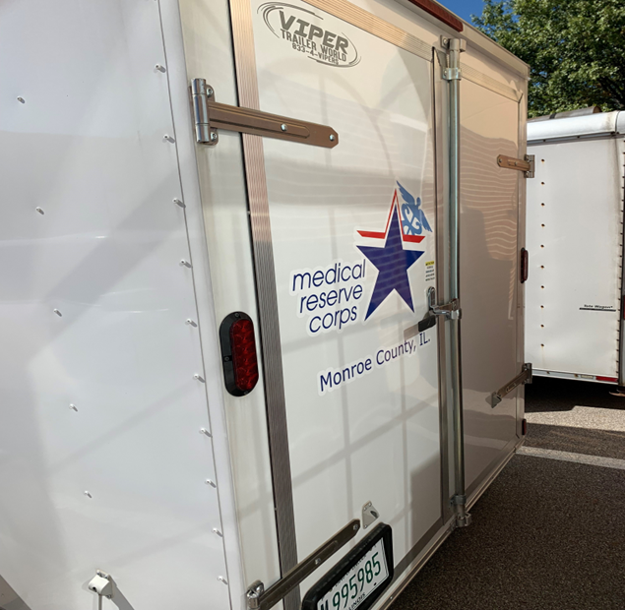

Monroe County, IL MRC Unit #2781 Trailer (6 ft. x 12 ft.) acquired in 2023!

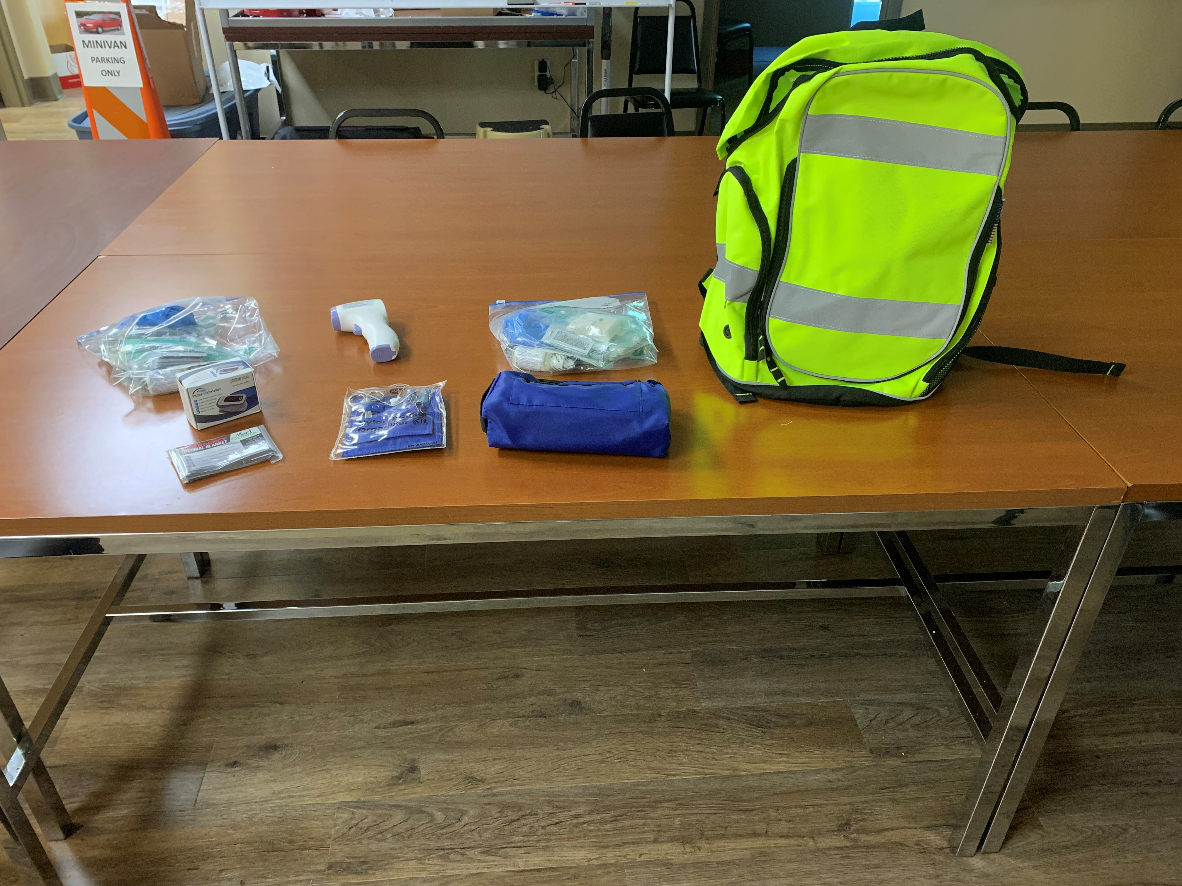

Medical supplies stocked in Nurse Backpacks

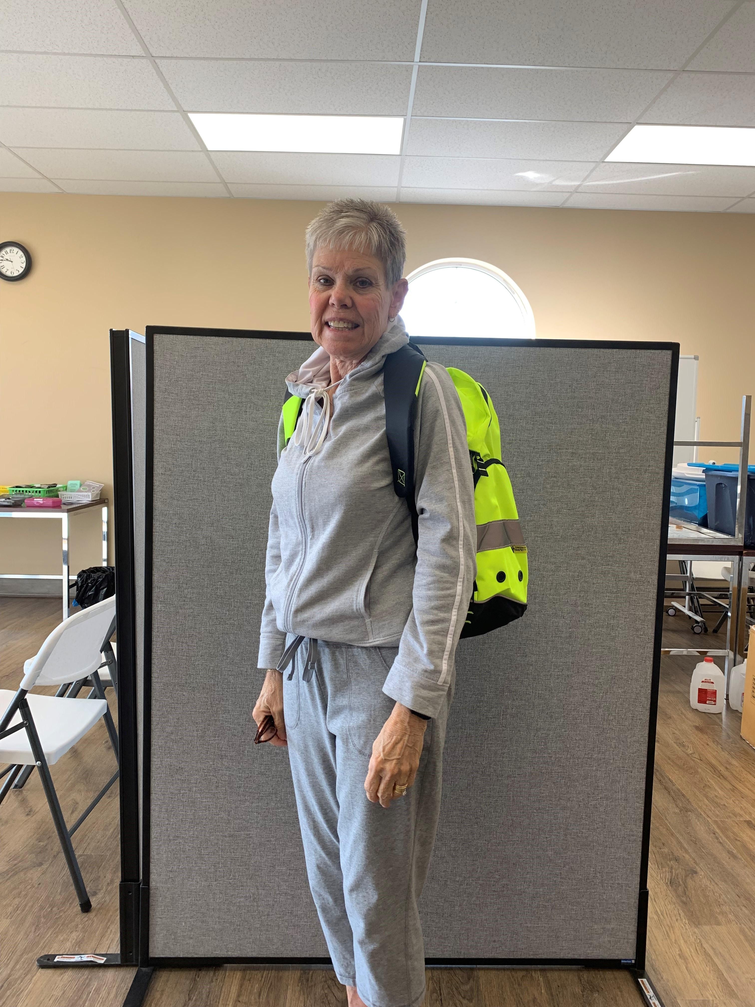
Marsha Wild, MRC Unit Leader wearing Nurse Backpack

