Quarterly Newsletter
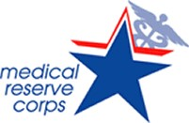
Monroe County, IL

Welcome to the eleventh quarterly newsletter of the
Monroe County, IL MRC Unit #2781

The following were some of our activities for this quarter:
- Our Emergency Response Coordinator and our MRC Unit Leader attended a St. Louis Regional Access & Functional Needs (AFN) Workshop in St. Louis, MO, on Thursday, February 26, 2026. We learned ways to meet the needs of individuals with functional needs and incorporate them into our Emergency Response Plans.
- Our MRC Unit participated in an Emergency Management Agency (EMA) Emergency Preparedness tabletop exercise on Tuesday, March 24, 2026, from 6:30 p.m. – 9:00 p.m. at Hope Christian Church, 9273 Coach Stop Road, Columbia, IL. Tabletop exercises are discussion-based sessions where team members meet in an informal classroom setting to discuss their roles during an emergency and their responses to a particular emergency situation. Several members of our Mental Health Specialty Team also participated and plan to have a meeting on May 20th to discuss it further.
- Our MRC Unit Leader conducted a “Call Down Drill” in Illinois Helps on Monday, March 23, 2026. Illinois Helps is our system for volunteer management. Please make sure to keep your contact information current and respond to these drills at www.illinoishelps.net
- Our MRC Unit Leader and 2 nurses from the Monroe County Health Department attended the YMCA Healthy Kids Day from 8a.m.-noon on Saturday, April 18, 2026. We distributed WIC, immunization, lead, infectious disease prevention and MRC information.
- Our MRC Unit Leader and one of the nurses in our volunteer unit attended a 2-day Medical Management of CBRNE (Chemical, Biological, Radiological, Nuclear, Explosive) Events training at Belleville Memorial Hospital on April 21-22, 2026.
- Our MRC Unit Leader attended 2 virtual trainings this quarter: Strategic Planning and Response provided by IDPH (Illinois Department of Public Health) Office of Preparedness and Response and Medical Leadership in Disaster Preparedness and Response provided by ASPR (Administration for Strategic Preparedness and Response).
- Our MRC Unit plans to display MRC information and answer questions about the MRC at Columbia EMS Open House on Thursday, May 14, 2026, from 4:30-7:00 p.m. and Monroe County EMS Open House on Friday, May 22, 2026, from 5:00-8:00 p.m. to help celebrate EMS Month!
Please let our MRC Unit Leader know if you are interested in CPR/First Aid training. We need at least six (6) individuals to conduct a class which is provided by a representative from Monroe County EMS. The training would be free of charge.
We continue our on-line training opportunities in MRC TRAIN. You can set up your account at https://www.train.org/main/welcome. Various trainings are offered to keep you informed and prepared as a volunteer.
To stay connected with our unit visit our Facebook page and Monroe County Health Department website at
https://monroecountyhealth.org/home/emergency-preparedness/volunteers/medical-reserve-corps/
THANK YOU, VOLUNTEERS, 😊 WE APPRECIATE YOU


ANNOUNCEMENTS
*** If you are an RN with current Illinois licensure and wish to continue, please remember to renew your license and complete your 20 Continuing Education Units by May 31, 2026. ***
The “Monroe County Retired Nurses” group will meet on Tuesday, May 26, 2026, at 11:30 a.m. at Mr. BBQ, Mystic Oaks Golf Course in Waterloo, IL. Kevin Scheibe from Monroe County EMA will be presenting on the “Scour hole/Potential levee breach problem in 2025”, followed by lunch (purchased on your own) and a meeting. Annual dues are $15.00. Please consider joining! Contact Marsha Wild at (618) 612-7105 if you have any questions or are interested in attending. You can find them on Facebook at Monroe County Retired Nurses.
Monroe County Health Department hours of operation:
As a reminder, the Monroe County Health Department is open Monday through Thursday 7 a.m. to 12:00 p.m., 1 p.m. to 5:30 p.m., closed on Fridays and holidays. Please call (618) 939-3871, ext. 210 for appointments.

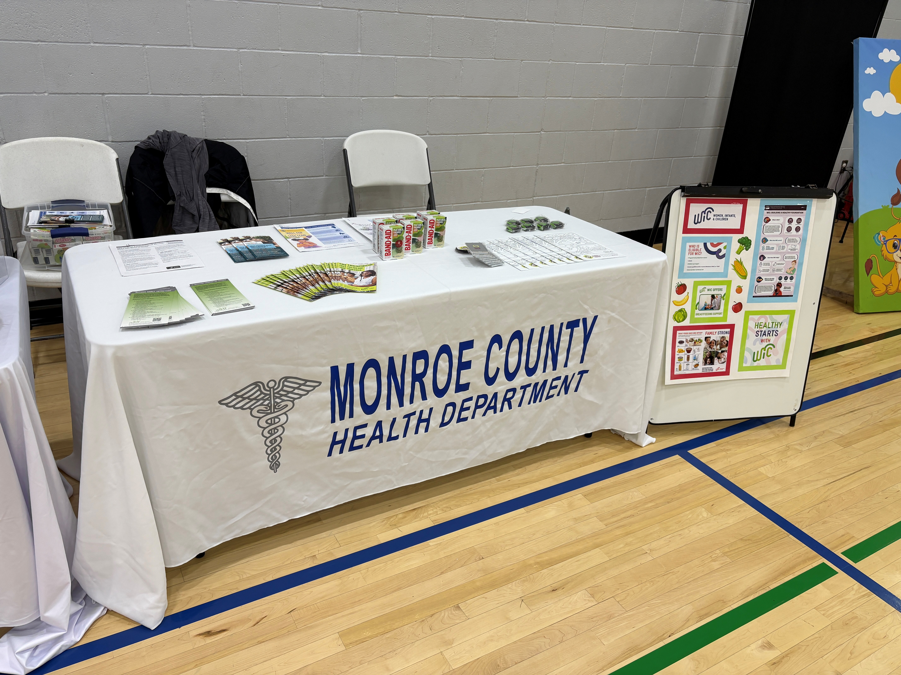

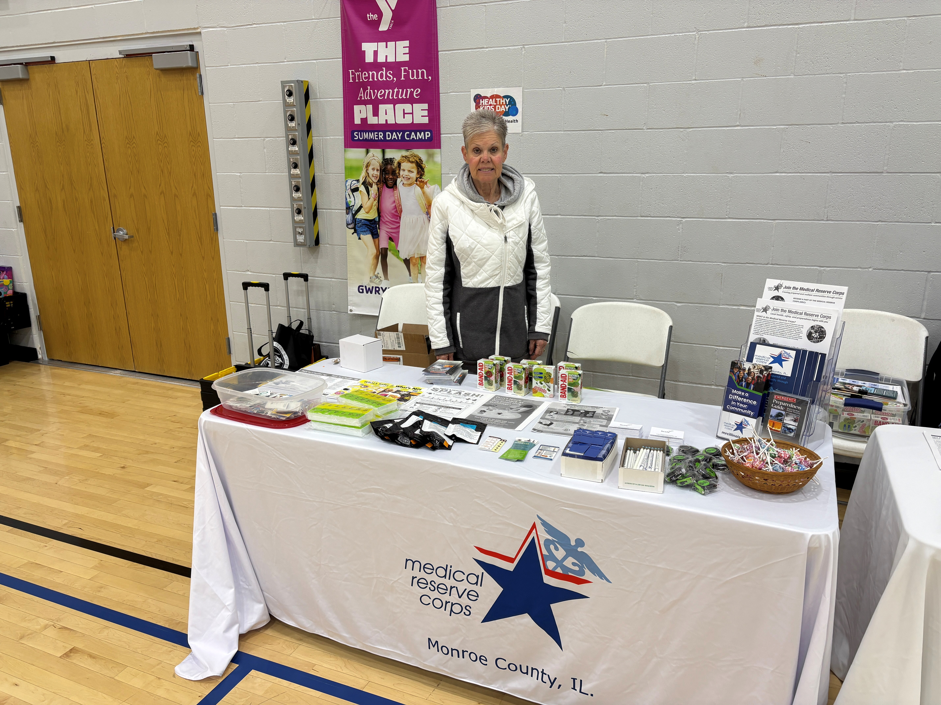

YMCA Healthy Kids Day, April 18, 2026

 Laugh every day, it’s good for your physical and mental health!!!





Suggestions/Questions??? Please contact our MRC Unit #2781 Leader at:
Marsha L. Wild MSN RN
Unit Leader
MRC Unit #2781
1315 Jamie Lane
Waterloo, IL 62298
mwild@monroecountyhealth.org
(618) 612-7105

