Quarterly Newsletter

Monroe County, IL

Welcome to the twelfth quarterly newsletter of the
Monroe County, IL MRC Unit #2781


The following were some of our activities for this quarter:
- Monroe County Health Department Administrator, Emergency Response Coordinator and our MRC Unit Leader attended a virtual exercise at Madison County Health Department, on Tuesday, June 9, 2026. The exercise was led by Illinois Department of Public Health (IDPH) and involved a scenario utilizing state laboratories and local health departments.

- Our MRC Unit Leader conducted a “Call Down Drill” in Illinois Helps on Tuesday, June 30, 2026. Illinois Helps is our system for volunteer management. Please make sure to keep your contact information current and respond to these drills at www.illinoishelps.net

- Our Emergency Response Coordinator and our MRC Unit Leader attended a virtual “National Access and Functional Needs Symposium” on July 7 & 8, 2026, addressing the needs of those with functional needs during emergencies.

- Our MRC Unit Leader & Monroe County EMS Director manned tables at the Monroe County Fair on July 19-23, 2026, distributing MRC, EMS, public health information and “Spin the Wheel” prizes!

- Our Emergency Response Coordinator and MRC Unit Leader attended Monroe County Local Emergency Planning Committee (LEPC) meeting on August 5, 2026. Monroe County Emergency Management Agency (EMA) is planning a full-scale exercise in the spring, 2027, to follow-up on the tabletop exercise conducted on March 24, 2026 involving many county first responders.

Please let our MRC Unit Leader know if you are interested in CPR/First Aid training. We need at least six (6) individuals to conduct a class which is provided by a representative from Monroe County EMS. The training would be free of charge.

We continue our on-line training opportunities in MRC TRAIN. You can set up your account at https://www.train.org/main/welcome. Various trainings are offered to keep you informed and prepared as a volunteer.

To stay connected with our unit visit our Facebook page and Monroe County Health Department website at
https://monroecountyhealth.org/home/emergency-preparedness/volunteers/medical-reserve-corps/
THANK YOU, VOLUNTEERS, 😊 WE APPRECIATE YOU!!!




ANNOUNCEMENTS

Monroe County Health Department:
Please note the following staffing changes at Monroe County Health Department:
John Wagner retired from the Monroe County Health Department on 6/24/2026. Happy Retirement, John!!!
Brian Eckert is now the acting Administrator and Elizabeth Brem has assumed the positions of Director of Environmental Health & Emergency Response Coordinator. Congratulations to both!!!
Colleen Goessling, LPN at Monroe County Health Department is retiring 8/31/2026. Happy Retirement, Colleen!!!
Chelsea Bivins, LPN, will be assuming Colleen’s position. Welcome Chelsea!!

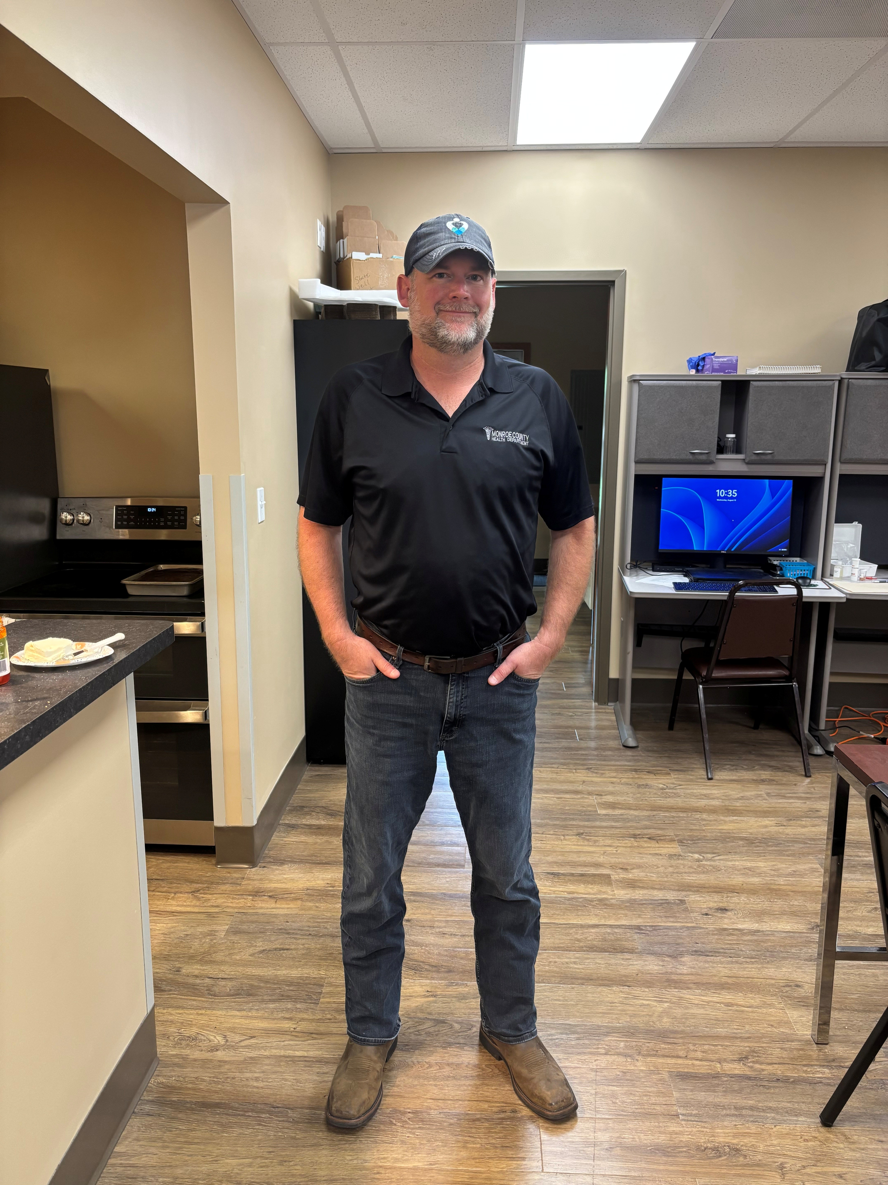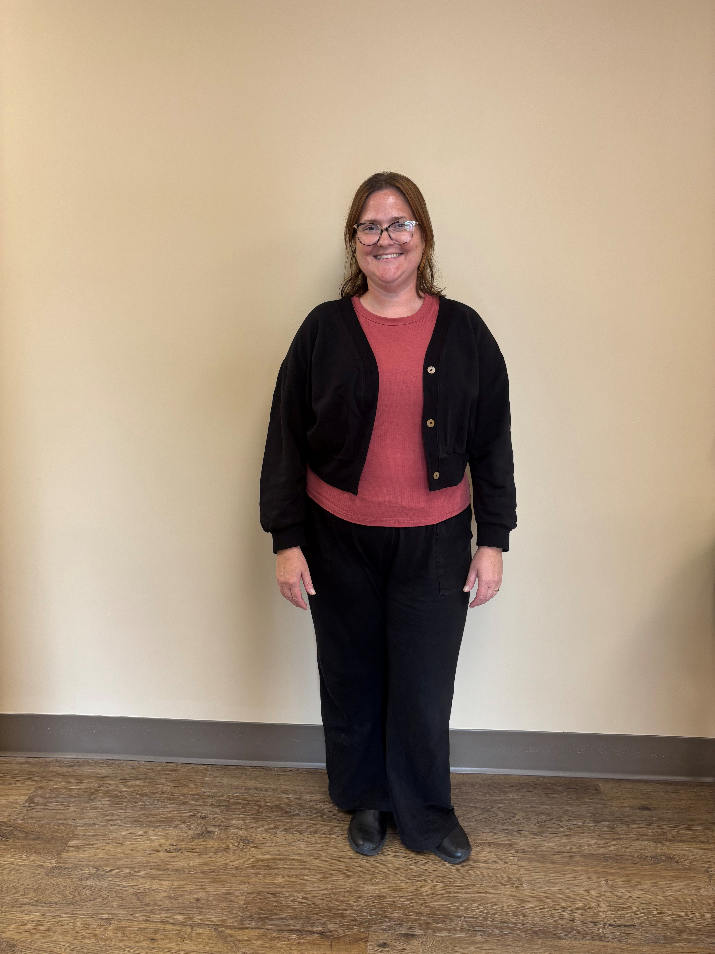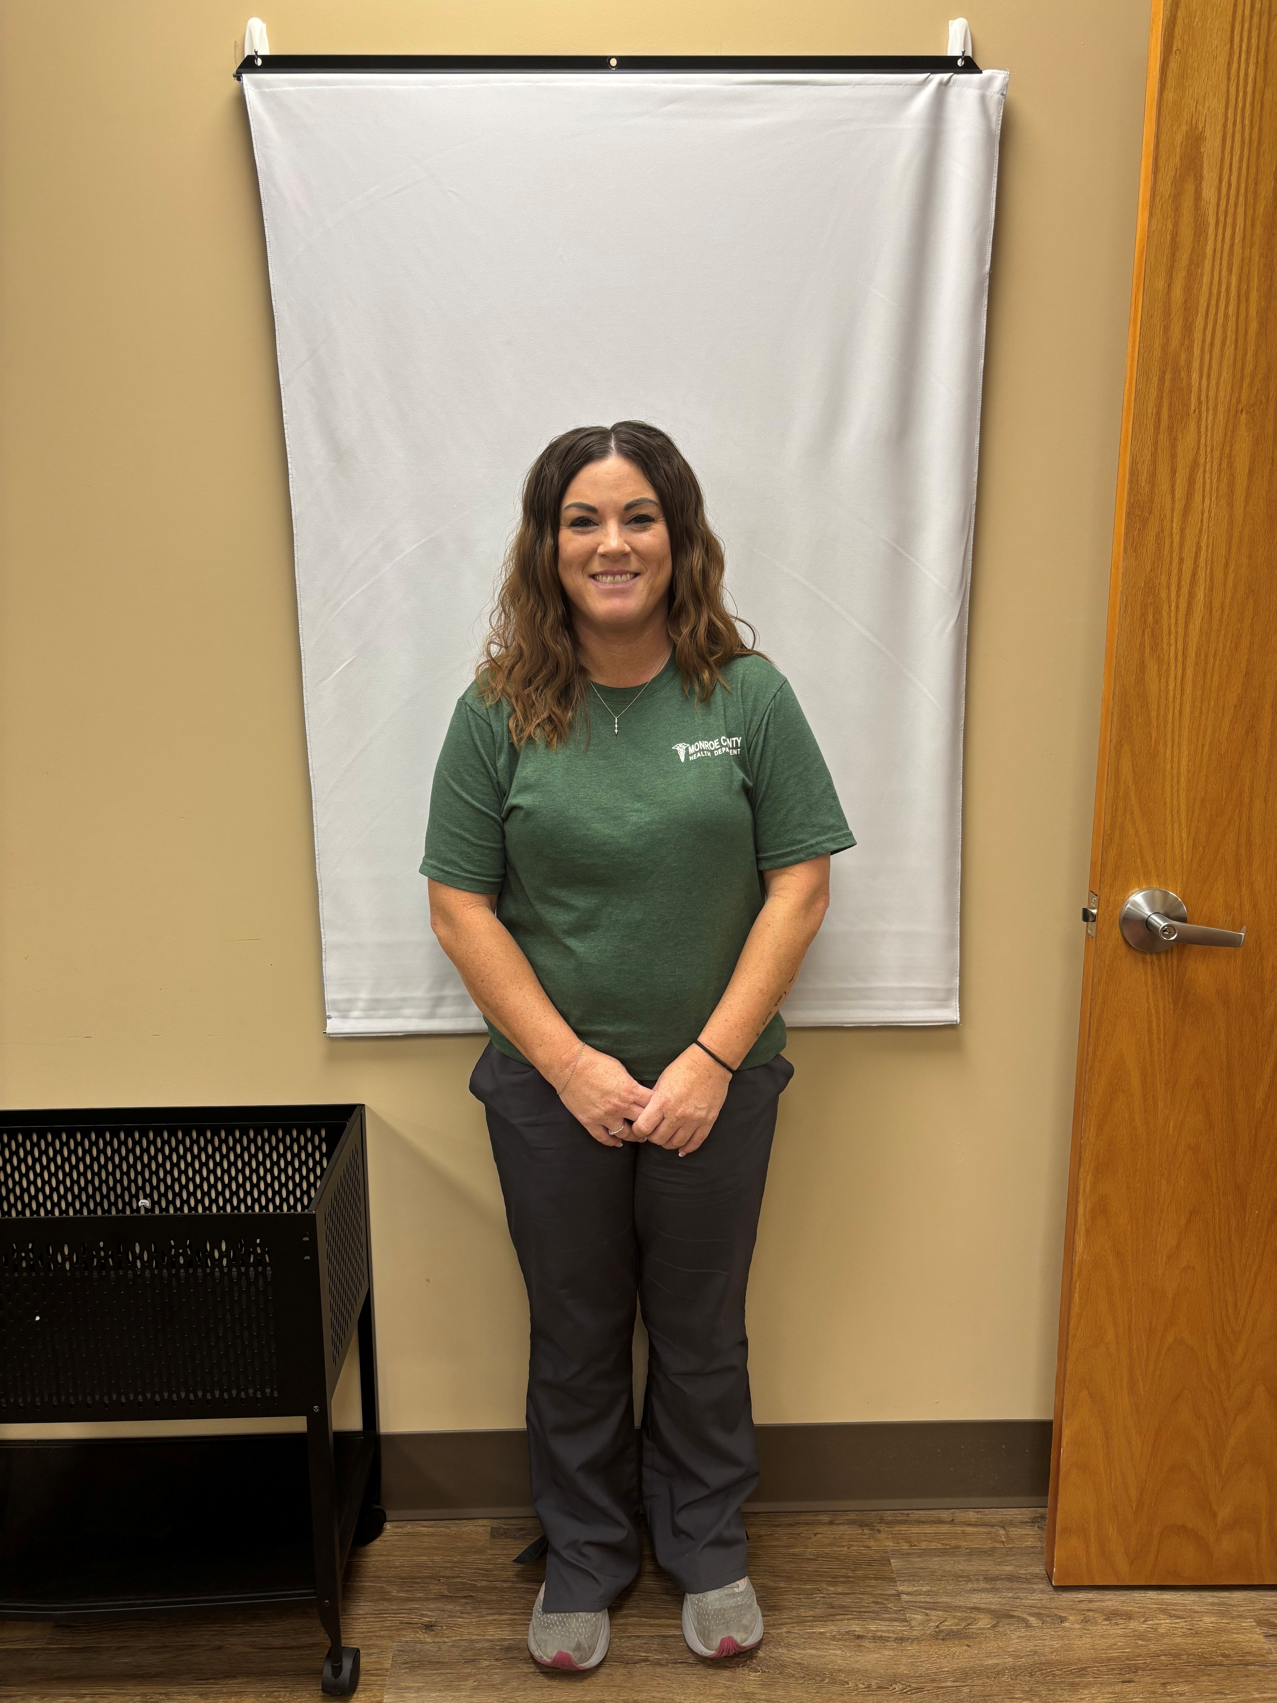
Brian Eckert Elizabeth Brem Chelsea Bivins
Administrator Environmental Health Director Licensed Practical Nurse
& Emergency Response Coordinator

Please remember the Monroe County Health Department is open Monday through Thursday from 7 a.m. to 12:00 p.m., 1 p.m. to 5:30 p.m. and is closed on Fridays and holidays. Please call (618) 939-3871, ext. 210 for appointments.

Monroe County Retired Nurses:
The group will meet on Tuesday, August 25, 2026, at 11:30 a.m. at Mr. BBQ, Mystic Oaks Golf Course in Waterloo, IL. “A Perspective on 9-11” will be presented by Eileen Berlin, retired Army nurse and possibly surprise guests, followed by lunch (purchased on your own) and a meeting. Annual dues are $15.00. Please consider joining! Contact Marsha Wild at (618) 612-7105 if you have any questions or are interested in attending. You can find them on Facebook at Monroe County Retired Nurses.
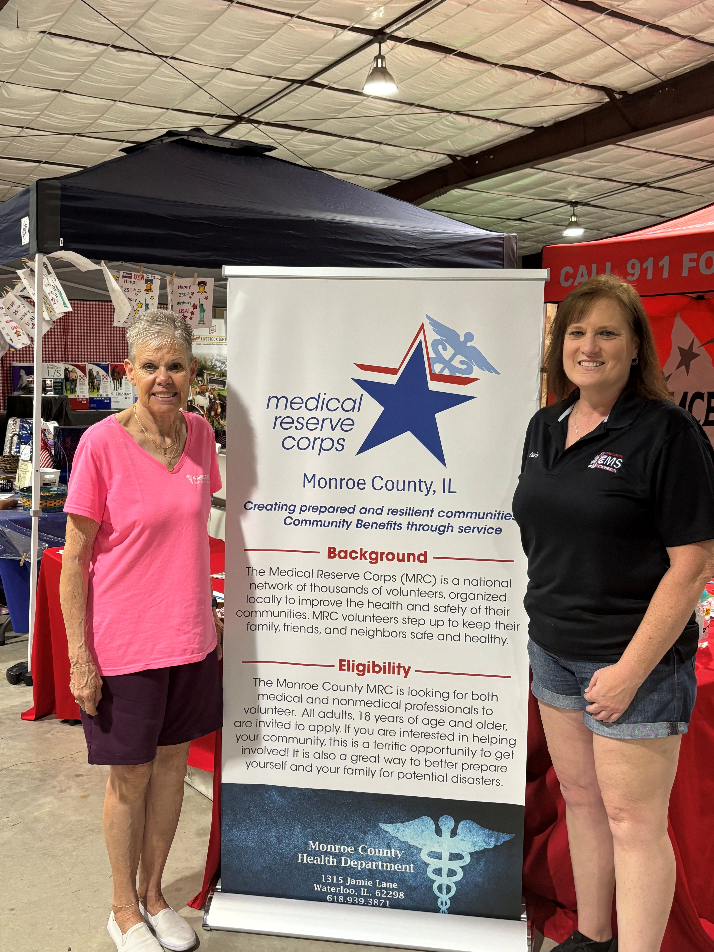Marsha Wild, Monroe County MRC Unit Leader & Carla Heise, Monroe County EMS Director
2026 Monroe County Fair
 Laugh every day!!!

Why are elevator jokes so good? Because they work on so many levels.

What do you call advice from a cow? Beef tips.

Why are pediatricians always so patient? Because they have little patients.

Why did the scarecrow win an award? Because he was outstanding in his field.

What do you call a pig that does karate? A pork chop.

What has a bed that you can’t sleep in? A river.

Why were the teacher’s eyes crossed? She couldn’t control her pupils.

How does the ocean say hello? It waves.

Apparently, you can’t use “beef stew” as a password. It’s not stroganoff

Monroe County MRC Unit #2781 Mission Statement

Our mission is to serve our communities primarily, and offer assistance to surrounding areas, in conjunction with our communities’ partners, in emergency and non-emergency situations. Staffing, supplies and equipment that we have on hand or will become available, will be provided on an as-needed basis, when possible.

Do you know anyone 18 years and older who would be interested in volunteering with our unit?

You do not have to have a medical background to be a member of our unit, register or submit an application.

Here is a link to register: https://www.illinoishelps.net//

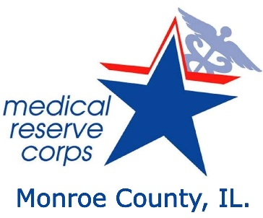

Monroe County MRC Volunteer Application
please print or type

Name:

Street (Mailing) Address

City State Zip

Phone: Home______________________ Cell_________________________
E-mail* Employer
* Your email address is required. It is the primary method of communication to MRC members about upcoming events, opportunities, and other information. Your email address will not be solicited.

Valid Driver’s License? Yes  No State: ________ DL#___________________
Any special accommodations or circumstances, required? Yes No
List: ____________________________________________________________________________

A Criminal Background Check is REQUIRED for all volunteers of Monroe County:
 Yes, I acknowledge a background check will be performed. Birthdate:___/___/___(mm/dd/yy)
Other names used: _________________________________________________________________________________
Do you speak another language? 1. 2.

Are you registered with any other volunteer/emergency management agencies? Yes No
List: ____________________________________________________________________________

How frequently, would you like to volunteer? Regularly _______ Occasionally _______
Only in emergency ________

Please indicate the duration to which you could commit if activated:
4 Hours  8 Hours 12 Hours

Please indicate the distance to which you could commit if activated:
_______Up to 25 Miles from Home ________25-50 Miles from Home
____50-100 Miles from Home _____Other ______ Distance is not an issue

(OVER)
Check activities which interest you or skills you possess:
______Administration _______Clerical _______Consulting _______Communications

______Development ______ Disaster Education ______Marketing _____ Public Relations

______Translating: Language __________ _________Youth Programs _______Other
Do you possess a professional license or certification? ________ License # _______________
State License Held: ______________ Current or expired? _______________
EMERGENCY CONTACT INFORMATION:
Name: __________________________________Relationship: __________________________
Home Phone: _________________________ Work Phone: _____________________________
Name: __________________________________Relationship: __________________________
Home Phone: __________________________ Work Phone: ____________________________
MEDICAL INFORMATION:
Describe any restrictions on your activities (physical, medical, mental):

Immunizations:_________________________________________________________________
Date of last tetanus shot: __________ Other Immunizations (smallpox, etc.) ______________
Volunteer Agreement
- The information provided is complete and true. If information given on this application is incomplete or untrue, I understand my assignment may be terminated.
- I agree to a background check, verification of the statements contained herein and additional screening procedures.
- I understand that my own insurance will be used as coverage for illnesses and injuries and that I am ultimately responsible for any costs incurred.
- I agree to respect the rights, property and confidentiality of emergency workers and individuals affected by disaster.
- I agree to uphold the mission of the health agency in the event of a disaster.
Privacy Act Statement: This information is requested by the Monroe County Medical Reserve Corps for the purpose of organizing volunteers and staff to respond to area emergencies, disasters, or public health emergencies. It will not be utilized or released for any other purpose without your express written permission unless required by law.
By checking this box and typing my name below, I am electronically signing this document.
Signature: Date:
Please Return: E-mail: mwild@monroecountyhealth.org • FAX: 618.939.4459
Mail: Monroe County Medical Reserve Corps. Unit # 2781 1315 Jamie Lane, Waterloo, IL. 6229

Questions???

Please contact our MRC Unit #2781 Leader at:
Marsha L. Wild MSN RN
Unit Leader
MRC Unit #2781
1315 Jamie Lane
Waterloo, IL 62298
mwild@monroecountyhealth.org
(618) 612-7105

